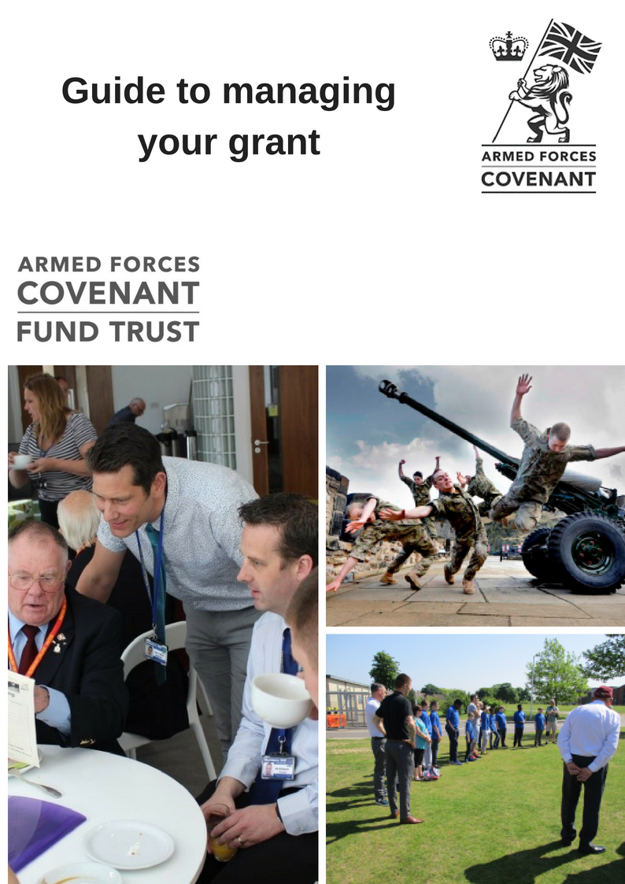

**Congratulations…**

…on being awarded a grant from the Armed Forces Covenant Fund Trust.

**The Armed Forces Covenant**  
*"To those who proudly protect our nation, who do so with honour, courage, and commitment, the Armed Forces Covenant is the nation’s commitment to you.  
It is a pledge that together we acknowledge and understand that those who serve or who have served in the armed forces, and their families, should be treated with fairness and respect in the communities, economy and society they serve with their lives."*

The Armed Forces Covenant is a promise from the nation that those who serve or have served, and their families, are not disadvantaged. The Armed Forces Covenant is also a promise of mutual support between the civilian and armed forces communities.

We wish you success with your funded project, and look forward to hearing about your progress - both in the formal reporting we ask for as part of our terms and conditions, and from your press cuttings, announcements and pictures, which we are happy to receive by email at any time.

The Armed Forces Covenant Fund Trust can only achieve its objectives through the programmes and projects that we support – that is, through you, the organisations to which we award grants.

So, we have put together this guide, which we hope will help you understand our expectations as well as give some guidance on promoting your work to add value to the grant you have received.

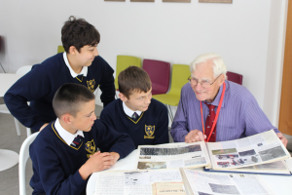

We want to continue to improve the way in which we manage our grant making and how we communicate with those who apply for and receive grants. If you have any suggestions on how we might do this, or comments on this guide, please do let us know using the email address **info@covenantfund.org.uk**

Please contact us on this email address if you have any questions regarding your grant/project.

**Section 1 - Getting started**

**If you have been offered a grant you will have received from us the following documents:**

* An offer letter
* Terms and conditions of grant
* A payment request form

**What we want back from you: 1-year grants**

**Within four weeks of receiving your offer:**

* A hand signed offer letter – returned by post along with a completed form requesting payment of your grant, ensuring it is completed fully with the requested evidence of your bank details.
* A draft copy of any partnership agreements in place with delivery or project partners. This should be sent by email to [info@covenantfund.org.uk](mailto:info@covenantfund.org.uk)

***\*Please note: Your offer will lapse if we do not receive this information within four weeks and you have not contacted us. We will be unable to make any payments until all the above information has been received correctly.***

**What we want back from you: 1-to-3-year grants**

**Within four weeks of receiving your offer:**

* A hand signed offer letter – returned by post along with a completed form requesting the first payment of your grant (depending on how you are being paid) ensuring it is completed fully with the requested evidence of your bank details.
* A draftcopy of any partnership agreements in place with delivery or project partners. This should be sent by email to [finance@Covenantfund.org.uk](mailto:finance@Covenantfund.org.uk)

**Within the first two months of receiving your offer:**

* Either a meeting or telephone call with us to discuss your project plans and milestones.

***\*Please note: Your offer will lapse if we do not receive this information within four weeks and you have not contacted us. We will be unable to make any payments until all the above information has been received correctly. More information on payments and monitoring can be found further on in this document.***

**Your offer letter**

This represents our formal agreement with you, and you need to check it includes all the correct details for your organisation, the amount of grant awarded and the purpose of the grant.

You will need to print out a hard copy and once you have read all the other documents, this should be signed by two suitably authorised people in your organisation. One of them must be the most senior staff member (the chief executive) or the chair of your board of trustees.

We advise that you get at least two copies signed, just in case it goes missing in the post and you need to re send it, this will save time.

You need to keep one hard copy for your own record purposes.

You must also advise your board that you have received a grant from the Armed Forces Covenant Fund Trust and ensure that you report to your board on the progress of your project.

Additionally, we will also require details of the main point of contact for your project.

This person will normally be the only person we will look to contact regarding your grant and your project, so please ensure you keep us updated with any changes to these details as your project progresses.

We may ask you to provide two further signatures on your payment form from your finance department – this is to confirm the account details are correct and will be in addition to your banking evidence document.

Please ensure you post the offer letter back to us within four weeks of receiving your offer pack, as failure to do so will result in your grant offer lapsing, unless you contact us to advise why.

**Terms and conditions of grant**

Please read these carefully – they describe the formal relationship between the Armed Forces Covenant Fund Trust and grant holders. They are standard and not negotiable on a case-by-case basis.

**Monitoring**

If you have received a grant that is for a **1-year project**, you will be expected to complete a progress form online at the half way point (that is six months after we receive your signed offer letter). This allows us to not only have an idea of your progress with the project but gives you the opportunity to advise us of any issues/changes in point of contact.

At the end of the one year, upon completion of your project, you will be asked to complete and end of grant form. You will receive an email at relevant times asking you to log into your grant account online with us to complete the forms. Please see the guide to completing report forms on our website for more detailed instructions for this and the list of questions within the forms.

*Please note that we may make minor changes to the wording or the order of the questions depending on feedback from previous grant holders.*

For grants received for **1-to-3-year projects,** we will expect more regular reports. These will be either quarterly, six-monthly or annually depending on the programme that you applied under. Your offer letter will explain how frequently these are needed along with a schedule of payments made on condition of us receiving a satisfactory report. More information on how large grant monitoring and payments are made is explained below.

**Milestone/Payment schedules and progress reporting for 1-to-3-year grants**

**Partnership agreements**

**If you are going to work in partnership with another organisation to deliver the project, and you need to enter into a partnership agreement with them in accordance with our terms and conditions, please can you send us the proposed draft agreement within four weeks of receiving your offer letter for our approval.**

**See Section 2 for more explanation of what we will do with these.**

**At the start of your project we will ask you to meet with us or arrange a call to discuss the plans for your project. At this point we will ask you to provide us with a milestone schedule to give an outline of key objectives set out within the timeline of the grant. We will require this before the first report is submitted.**

**Grants that are paid in instalments require completion of a report on the previous payment period before the next instalment of your grant is paid. The main point of contact (which should be the person who is responsible for the grant account online) will be contacted via email advising them their report is waiting their completion and when it is due by. The earlier this is completed (to our satisfaction), the earlier the next payment will be made.**

**Part of this report will require you to upload financial evidence of the grant spend against the budget you submitted within your application. This is so we can clearly see your grant expenditure.**

**Press cuttings/media coverage/photos**

We would like to receive press cuttings (do scan them and email as attachments, or send us the web links, or you can upload them into your report), information about media coverage and photos relating to your announcement of getting a grant and as your project progresses. See more information in **Section 5** below about what we will use them for.

**Acknowledging the Covenant Fund**

This guide will give you some ideas about how we would like you to do this, but please remember that acknowledging our funding in any printed documents, websites or on social media is a fundamental term and condition of our funding and we expect to see the logo used where possible.

**Section 2 – What we will do**

**Provide advice on draft partnership agreements**

If you need a partnership agreement, you will need to send us a draft version. We will send you comments back on this – either to confirm that they comply with our requirements or to make suggestions.

**Please do not sign any partnership agreement until you have heard from us confirming is it acceptable to us and also that your position as the accountable body for the grant is not undermined. You must not make any payments to your delivery partner until we have approved the partnership agreement and you have finalised it with your delivery partner.** [See our website and the guidance notes for the priority under which you are funded for more information about partnership agreements]

**Pay your grant**

After we receive your documents, we will check we have all the correct information that we need to pay your grant (including verifiable details of your bank account, the signed offer letter, accepted partnership agreements). Once we have done this, we will process the first payment. If we have all the information we need, we aim to do this within 15 days of receiving your paperwork, but you will need to allow at least 30 days for receiving payment, providing there are no errors within the paperwork you have submitted. Therefore, for your own cash flow planning, we strongly advise you not to begin your project until payment has been received into your account. Subsequent payments (for all grants other than 1-year grants, which only have one payment) will be made after receipt of completed milestones received, and progress reports submitted.

**Monitor your progress**

We use your progress reports for several purposes. Firstly, we use them as evidence that public funds are being spent according to the terms under which they have been awarded. For a large grant, this needs to be completed in reference to the previous payment period (meaning the first report will be submitted with request for the second payment and so on).

**Your progress report should tell us what you have done during that period and explain any variances to your project and what you have spent.**

**Before we will issue the next payment, we will check this report against the milestones you will have also submitted, plus check your bank details against the banking evidence document.**

**We will contact you if there are any issues before payment can be released or if we require further clarification.**

We do, of course, accept that there might be changes in timing, specific spend or in delivery – see ‘Changes to your project’ **in Section 3** below – and we do expect to see these particularly in large and complex programmes of work.

Secondly, we learn from your progress report about issues which might be useful to other grant holders, to our own decision making on other grants and in planning for new priorities. We will not pass on any specific details to other organisations without your permission – but may put them in touch with you if we think it would be advantageous to either of you.

**Make monitoring visits, request meetings and phone calls**

We may ask if we can come and visit you to discuss progress and/or to see the work you are doing. If we do ask to arrange a meeting, this does not necessarily mean we have any concerns about how your project is progressing or how you are managing your grant - we need to hear from, and learn from, successful projects as well as those who might be having difficulties or suffering delays. Of course, if you do run into problems, we might agree that it would be useful for us to talk on the phone or have a meeting.

**Attend events and special occasions**

We may be able to attend if you are having open days, celebrations or other events – or to suggest regional colleagues or other people with whom we work who might like to come instead. Do include us in invitations as, even if we can’t come, it helps us to understand how your work is progressing.

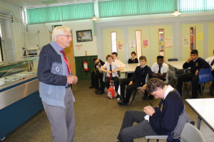

**Section 3 – Keeping in touch**

We want to hear from you whilst your project or programme of work is underway. As already mentioned, we expect regular formal reporting and will be glad to see press and publicity material and hear of your successes. We also need to hear from you about the following things.

**Significant changes to your organisation**

As you will see in your terms and conditions, we need to know if there are any changes to your organisation’s management, governance or finances that might impact on your ability to deliver the project we are funding.

**Changes to your project**

We understand that there may be changes to your plans – for good reasons as well as in response to difficulties or challenges you or your partner organisations might be facing. If these are material – such as changes to your budget, differences in your beneficiary groups or numbers, or timing differences of more than a few weeks, we would expect to hear from you to seek our agreement to use the grant in this new way. In most circumstances we are unlikely to refuse – but we still need to know as your change might impact on our own reporting and accounting for committed funds. If we can easily agree the change, we will confirm a ‘variation of grant’ to you in writing. If the changes are very significant, we may need to talk to you about the implications and whether there are further steps we need to take. If in doubt about whether we will be interested in the change or delay, do let us know anyway and we can quickly deal with anything we regard as normal project management issues.

**Changes to contact details**

Please do update us immediately with changes of personnel, addresses, email addresses and phone numbers of those who you have told us are the main contacts for the grant.

This is particularly important as there can only be one main contact linked to the grant account online and this will be the person who can access any required reports to be completed.

Please email [info@covenantfund.org.uk](mailto:info@covenantfund.org.uk) if you have any questions on this or need to change your contact details.

**Section 4 - Collecting and managing data**

As you begin your project, we suggest that you read the monitoring proforma and revisit your application to us in order to plan what data you must collect before, during and on completion of the funded project or programme of work.

We hope that there is nothing we ask you to collect or analyse that you do not already hold or would wish to in order to evidence your work to any stakeholders, other funders or for internal management reporting.

Section 5 – Promotion and publicity

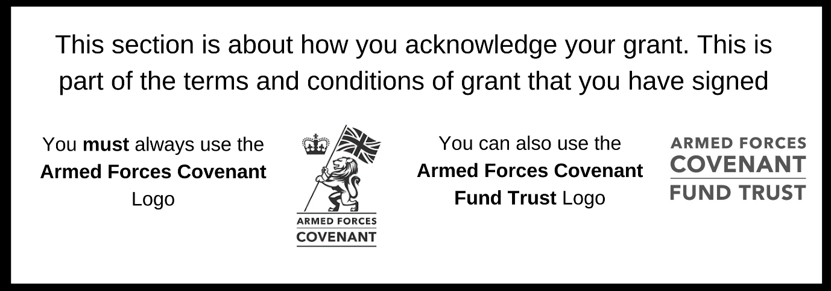

**When your project is underway**

Celebrate what you are achieving by letting people know about your activity.

Local newspapers always like to hear about great things going on in their local community. Write a press release; this should ideally be two or three paragraphs long and talk about why your project is exciting. Put some information about your organisation in a ‘notes to editors’ section below. Don’t forget to say that your project is funded by the **Armed Forces Covenant Fund Trust**.

Your press release can also go wider; do consider sending to your local radio stations or even local TV news.

**When your project is completed**

It’s time to celebrate the achievements of your work.

* Think about what really worked well on your project- did it bring people together? Perhaps approach a few people involved in your project to see if they will give you some quotes that you could use in a press release or story on your website that you could promote through social media
* Did you develop or purchase something that will have a longer lasting impact? Get some photos and send out a press release.

**Using the brand**

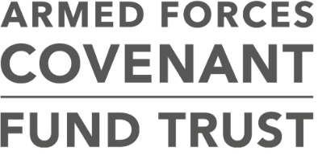As part of your terms and conditions of grant, you have undertaken to use the Armed Forces Covenant Fund Trust branding. This lets people know that the funding for your project is funded from the Covenant Fund. It is important that you publicly acknowledge the funding that your project has received and we will ask you, as part of your grant monitoring, to show us how you have done this. If your project has difficulties in being able to use our brand, then it is important that you talk to us about this.

This guide will provide you with more information on how to use the brand, particularly in how to use the Armed Forces Covenant logo. This is the logo which contains the lion and the words ‘Armed Forces Covenant. The ways in which you use the brand to acknowledge your grant should be proportional to the size of your award. If you are not sure if you have done enough, we are happy to give advice.

However you choose to acknowledge your grant, it must be for the life of your project. This will depend on the nature of your grant - if it funds services, it will be for the duration of the services we funded; if it is for a capital project, as long as that project exists in the form we funded.

**Where to use the logo**

Everybody who visits your project, takes part in your activities or uses your services that are being supported through your grant should be able to see that it was funded by the Armed Forces Covenant Fund Trust with funding from the Covenant Fund which supports the Armed Forces Covenant.

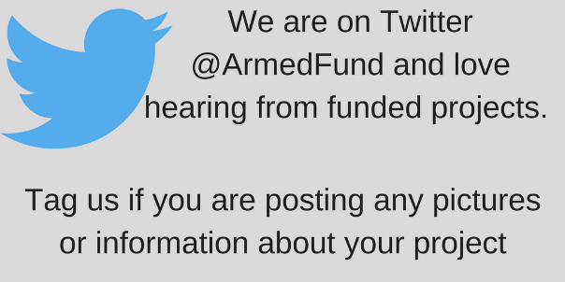The following section gives more detailed information on ideas using the Armed Forces Covenant logo. However, this isn’t exhaustive, and you may have ideas of your own, more suited to your project. We’d love to see any innovative uses of our logo if you have them. The important thing is to let people know about your funding.

You can also use the logo for the Armed Forces Covenant Fund Trust. However, if you only have room for one logo, you must use the Armed Forces Covenant Fund logo (featuring the lion).

**Websites and social media**

If your project has a website, our logos should appear on the home page. Please ensure that they are large enough to be legible on screen. We would expect to see acknowledgement of your grant on your website.

**Using the logo on a building**

If we have funded capital or building works as part of your project then this must be publicly acknowledged. You can do this through signs, plaques or by having the logo on site boards and hoardings while your project is under construction. If you are using a plaque, please make sure it is placed somewhere where it can easily be seen by visitors to your building. We understand that sometimes there may be a cost in doing this and would be happy to talk with you about whether this can come out of your grant. In some circumstances we may be able to supply plaques. Our plaques will only contain the Armed Forces Covenant Fund Trust and Covenant Fund logos. If you wish to have your logo or other branding on the plaque then you would need to make your own arrangements.

**Using the logo on equipment**

If you purchase a vehicle with your grant, then you must display the Armed Forces Covenant logo where it can be easily read. If it is not possible to affix a sticker on equipment, you should acknowledge our contribution by other means, for example a mention on your website or a nearby plaque.

**Events**

Your grant must be acknowledged at any event you host. This can include launch or celebration events or conferences. We would also like you to tell us about any events that you are having in advance.

**Publications and printed material**

The Armed Forces Covenant logo must be included when producing any form of promotional or publicity materials including posters, press releases, leaflets, brochures and annual reports. The Armed Forces Covenant Fund Trust logo can also be used. You may decide to add our logo to your stationery by having it commercially printed or adding it to your templates. Our logo must be easily visible and conform to our minimum size requirements.

**Press releases**

All press releases about your work funded by the Covenant Fund should also include the Armed Forces Covenant logo and can also contain the Armed Forces Covenant Fund Trust logo. Please send us copies of any press releases that your project sends out. You will also need to keep copies of these to include with your end of project report, along with details of any other promotional activity that you have undertaken.

**Advertising**

You will need to include our logo if you are advertising your project or recruiting for staff or services which we have funded. If the cost of advertising space will not allow you to include the logo in a size that is clearly legible, the following text can be used instead: ***Funded by the Armed Forces Covenant Fund Trust with funding from the Covenant Fund.***

**How to use the logo**

You should register to download the brand logos using this link: <http://defencebrandportal.mod.uk/bms/?link=19CE5405>

The logos for the Armed Forces Covenant can be found within the ‘Schemes and Campaigns’ section. Do be aware that the Covenant Fund is part of the wider Armed Forces Covenant and that some of the resources that are available on this site may be less relevant to your work.

This is the logo illustrated here. When downloaded, the logo will open in a photo viewer. You may find it helpful to open it in another format such as a paint programme, which will enable you to cut and paste it into other documents.

There are several logos that are available for website and professional use. If you are working with a designer or other communications professional as part of your project, then you may like to direct them to the Defence Brand Portal, or to the brand guidance available at [www.armedforcescovenant.gov.uk](http://www.armedforcescovenant.gov.uk). You can also read the terms and conditions regarding use of the logo on this site.

You can download the Armed Forces Covenant Fund Trust logo from [www.covenantfund.org.uk](http://www.covenantfund.org.uk) in the ‘for grantholders’ section.

There are a few important points to be aware of when using the logo.

* Please don’t change the colour of the logo. If you need a colour logo then an additional secondary colour palette containing three colours is available.
* Please make sure that when you use the logo it is bigger than 20mm along the bottom of the logo on printed materials. This ensures that people can see it effectively.
* Please try to keep some space around the logo, so that it stands out. As a minimum, the space around the logo should be the size of the crown within the logo.
* Please make sure that the logo is not fuzzy or distorted when you are using it.

More detailed information is available in the Armed Forces Covenant Brand guidance, which is available from the Defence Brand Portal.

If you have any queries, please contact us at [info@covenantfund.org.uk](mailto:enquiries@covenantfund.org.uk)

**Photography and video**

It’s great to send us pictures and videos of your funded work. We know that projects supported through the Covenant Fund have been delivering great support to the Armed Forces and wider communities. We want to be able to celebrate the work that your project is delivering and inspire others to think about the Armed Forces Covenant.

**Gaining consent for photographs and video footage**

You need to get consent from people you would like to photograph or film, especially if you plan to use the images for publicity purposes – both in print and online. This includes your social media activity.

When you seek consent, we recommend that you produce a form that you can get people to read and complete at your event. It is also a good idea to let them know an event will be filmed or photographed when they arrive. Suggested content for you consent form can be found in the sample document contained within this guidance.

**How your photographs and video footage may be used**

We may wish to use photographs and videos that you have produced in publications and wider promotional activity about the Covenant Fund. This may also raise awareness of your project among the general public. We can only do this if we are sure that the people featured in photographs or videos have consented to their image being used in this way. When you send us pictures or videos of your project please let us know if we can use these for wider publicity purposes. Please don’t send us copies of completed consent forms unless we specifically request them but do keep copies of completed consent forms with your grant records.

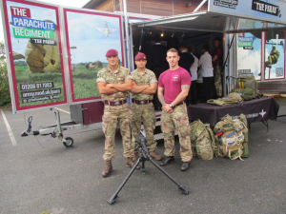

**Sample form**

**Film and photography consent form**

Thanks for coming to our project. We are recording our event and may use some of this material to promote our work. Our funders may also use pictures and videos from this event for promotional purposes. If you are happy to be included in this activity please complete the form below.

|  |  |
| --- | --- |
| Name |  |
| Address |  |
| Date of Birth |  |

1. You grant permission to the (insert your organisation’s name and address here) and to the Armed Forces Covenant Fund Trust to use and disclose your:

(a) image, physical likeness and name (images); and

(b) voice and sound (sounds), without restriction in any media or format.

You will let (insert your organisation’s name here) know if you wish to withdraw this permission.

2. Your permission includes the (insert your organisation’s name here) and the Armed Forces Covenant Fund Trust using your images or sounds for any publicity or advertising in connection with its work, and disclosing your images or sounds to other organisations (such as media and advertising agencies) for publicity purposes.

3. You have volunteered your images and sounds and agree that you will not receive or request any payment, royalty or other form of consideration for your images, sounds or participation in any project of the (your organisation’s name here).

Signature_____________________________ Date_______________

**If the individual is under 16 years of age their parent, legal guardian or authorised legal representative must sign below:**

4. I confirm that I am the parent, legal guardian or authorised legal representative of this individual and warrant that I have lawful authority to sign this consent form for and on their behalf.

5. I have read, and understand the terms and conditions and consent to the individual providing their Images and Sounds on these terms and conditions.

Signature_____________________________ Date_______________

***About us***

**The Covenant Fund was previously administered by an in-house MOD team and the funding has moved to the new independent trust as from 1 April 2018.**

**The Armed Forces Covenant Fund Trust manages the grant programmes funded by the Covenant Fund. You can find out more about our work at** [**www.covenantfund.org.uk**](http://www.covenantfund.org.uk)**.**

**The Covenant Fund is an annual grant of £10 million which is paid to the Armed Forces Covenant Fund Trust to fund grant programmes that support the Armed Forces community.**

**The Covenant Fund makes grants in support of the Armed Forces Covenant. There are four overall themes that the Covenant Fund must consider now and in future years when making decisions.**

* **Non-core healthcare services for Veterans**
* **Removing barriers to family life**
* **Extra support after service for those that need help**
* **Measures to integrate military and civilian communities and allow the Armed Forces community to participate as citizens.**

***About the Armed Forces Covenant***

**The Armed Forces Covenant is a promise from the nation that those who serve or have served, and their families, are treated fairly.**

**You can find out more at** [**www.armedforcescovenant.gov.uk/**](https://www.armedforcescovenant.gov.uk/)



**Contact details**

[**www.covenantfund.org.uk**](http://www.covenantfund.org.uk)

[**info@covenantfund.org.uk**](mailto:enquiries@covenantfund.org.uk)