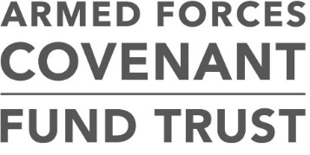
Grants awarded under the Strengthening Delivery of the Armed Forces Covenant programme Round 2
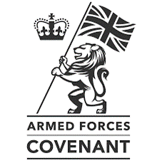
81 Lead LAs were awarded £3,068,055

 | Lead Local Authority | Local Authority Locations | Grant Amount (£)
Round 2 | Cambridgeshire County Council | Peterborough | 88,541
 |  | Cambridge
 |  | South Cambridgeshire
 |  | Huntingdonshire
 |  | East Cambridgeshire
 |  | The Fens
 | Carmarthenshire County Council | Carmarthenshire | 152,700
 |  | Ceredigion
 |  | Pembrokeshire
 | Charnwood Borough Council Rushcliff BCC | Borough of Melton | 150,650
 |  | Charnwood
 |  | Rushcliffe
 | COBSEO | Northern Ireland | 300,000
 | Derbyshire County Council | North East Derbyshire | 50,000
 |  | Derbyshire
 |  | Derbyshire Dales
 |  | Derbyshire Dales
 |  | South Derbyshire
 |  | Derby
 | Dorset County Council | Dorset | 234,786
 |  | Poole Borough Council
 |  | Bournemouth
 |  | West Dorset
 |  | Weymouth and Portland
 |  | North Dorset
 | Kingston Upon Hull City Council | Kingston upon Hull | 131,450
 |  | East Riding of Yorkshire
 |  | North East Lincolnshire
 |  | North Lincolnshire
 |  | Metropolitan Borough of Doncaster
 | Lancashire County Council | Lancashire | 152,700
 |  | Preston, Lancashire
 |  | Borough of Burnley
 |  | Borough of Chorley
 |  | Borough of Fylde
 | London Borough of Lewisham | London Borough of Lewisham | 198,240
 |  | City of Westminster
 |  | London Borough of Enfield
 | Milton Keynes Council | Milton Keynes | 91,500
 |  | Bedford
 |  | Central Bedfordshire
 |  | Luton
 | Neath Port Talbot County Borough Council | Neath Port Talbot | 88,083
 |  | Bridgend Borough
 | North East Lincolnshire Council | North East Lincolnshire | 79,050
 |  | North Lincolnshire
 |  | East Lindsey
 | Nuneaton and Bedworth Borough Council | Nuneaton and Bedworth | 146,000
 |  | North Warwickshire
 |  | Warwickshire
 | Portsmouth City Council | Portsmouth | 152,997
 |  | Southampton
 |  | Isle of Wight
 | Rhondda Cynon Taf Council | Rhondda Cynon Taf | 150,000
 |  | Cardiff
 | Rhondda Cynon Taf Council | Rhondda Cynon Taf | 140,000
 |  | Merthyr Tydfil County Borough
 |  | Vale of Glamorgan
 | Rotherham Metropolitan Borough Council | Rotherham | 101,050
 |  | Metropolitan Borough of Barnsley
 |  | Metropolitan Borough of Doncaster
 |  | Sheffield
 | Rutland County Council District Council | Rutland | 111,550
 |  | Harborough District
 |  | South Kesteven
 | Surrey County Council | Surrey | 147,888
 |  | Kent
 |  | Hampshire
 |  | West Sussex
 | The County of Herefordshire District Council | Worcestershire | 246,820
 |  | Herefordshire
 |  | Shropshire
 |  | Telford and Wrekin
 | Wiltshire Council | Wiltshire | 154,050
 |  | Cornwall
 |  | Devon
 |  | Plymouth
 |  | Gloucestershire
 |  | Somerset
 |  | North Somerset
 |  | South Somerset

