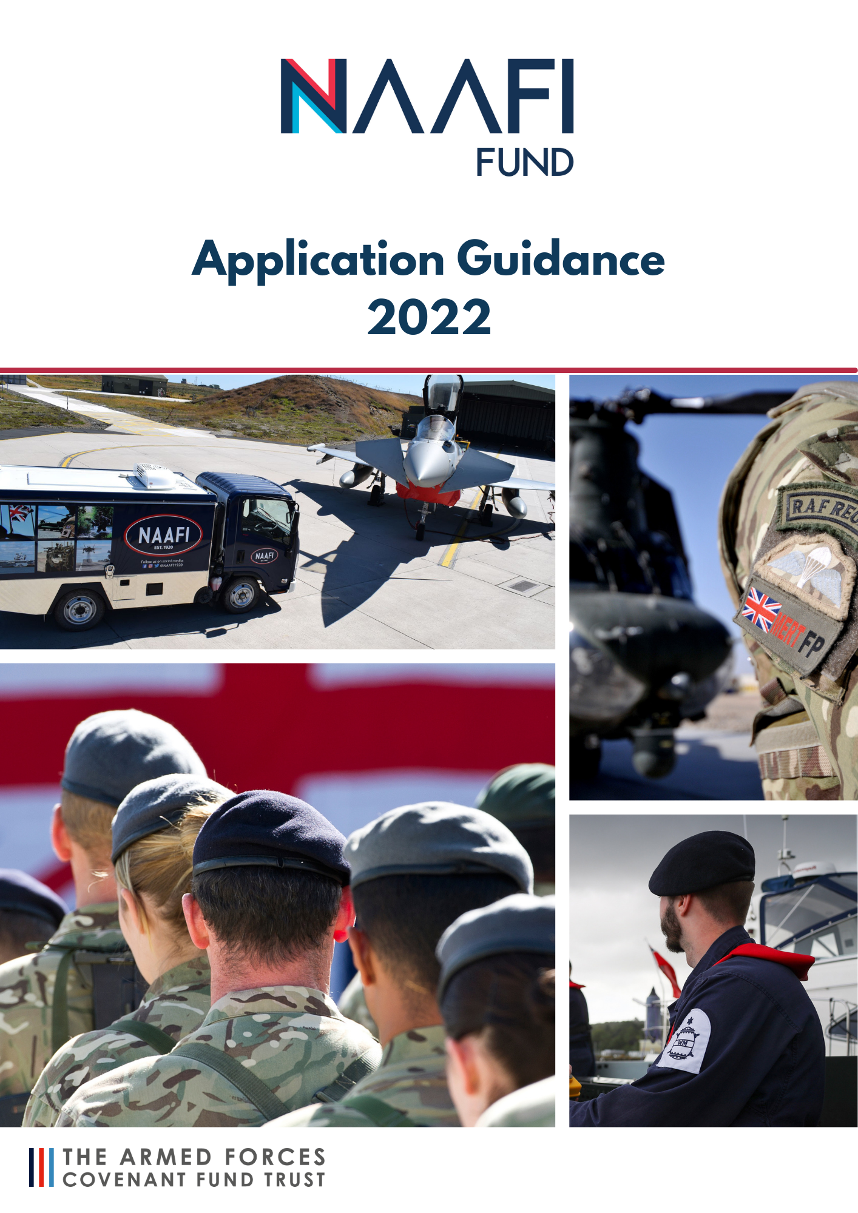

The Armed Forces Covenant Fund Trust
NAAFI FUND
2022/23

PROGRAMME GUIDANCE

The NAAFI Fund makes grants to UK Armed Forces units, located in the UK or overseas; for projects that improve the quality of life for serving personnel and their families.

The NAAFI Fund is a rolling programme. There will be one round of the NAAFI Fund per year. This guidance is to help you apply for a grant in 2022. Even if you have applied in a previous year, please read this guidance as some of the details may have changed.

In summary, the first step is to apply to NAAFI with your summary before 25 May 2022 and if successful, complete your full Application on the AFCFT website by 13 June 2022. You will get notification about whether you have been successful or not before the end of August 2022.

The NAAFI Fund comes from funding made available by the Navy, Army and Air Force Institutes (NAAFI). NAAFI is the in-house service provider to HM Forces of catering, retail, leisure, and facilities management services.

The Armed Forces Covenant Fund Trust administers the NAAFI Fund on behalf of NAAFI.

Who can apply?

This programme will make grants to Armed Forces units for projects that have a positive impact on the lives of serving personnel and their families.

Only British Armed Forces can apply. Applications are welcome from units based in the UK and overseas. We welcome applications from all three services.

Charities and other organisations are not eligible to apply for this programme. An Armed Forces unit could, however, choose to work with a charity or other local organisation to deliver their project.

The application should be made by the person in the unit who would be responsible for delivering the project if successful. Please think carefully about who this should be as it may cause delays to your project if you were successful, and your main point of contact has been deployed or posted out.

Your Commanding Officer or Officer in Command will need to provide a letter of endorsement as part of the full application process to show that your local chain of command supports the project and its delivery.

If you applied last year, whether you were successful or not, you will need to read this guidance to ensure that your project idea fits the criteria of the NAAFI Fund. You will also need to send your project idea to NAAFI. Any codes that you were issued previously are no longer valid.

If you were issued with a code last year but did not complete your full application for a grant, you will need to re-send your 50-word summary to NAAFI. They may be able to issue you with a new code if your project idea still meets the programme criteria.

What can a grant be used for?

The NAAFI Fund will make grants towards project or activities that improve the quality of life for serving personnel and Armed Forces families living on or near Armed Forces bases or units.

The NAAFI Fund will make grants both now and in the future. The Fund will run for a
minimum of a 10-year period. This year, the focus of the Fund is on projects or activities that can support health and wellbeing including mental health.

Grants should be used to help serving personnel and their families be healthier and more active as well as providing activities or enhancing spaces to socialise in order to improve their mental health.

This year, we have two streams of funding:

Tier 1 - Grants between £5,000 and £25,000,000
Tier 2 – Grants over £25,000 up to £50,000. These grants will offer the opportunity for some more ambitious projects for programmes of work; however, it is likely that we will limit how many grants of this size will be awarded during 2022/2023.

The types of projects that the NAAFI Fund may support in 2022/23 might be:

- providing equipment for projects that encourage serving personnel and families to be more active
- refurbishing or enhancing communal spaces, for example creating games rooms with pool tables or electronic gaming equipment that could be used as a recreational space by serving personnel in single living accommodation
- creating indoor or outdoor spaces that encourage people to socialise on the unit
- providing or improving play areas and equipment for children from Armed Forces families
- providing a bank of mountain bikes that can be loaned out for serving personnel and families to explore the local countryside

This list is to give examples only.

Your project should:

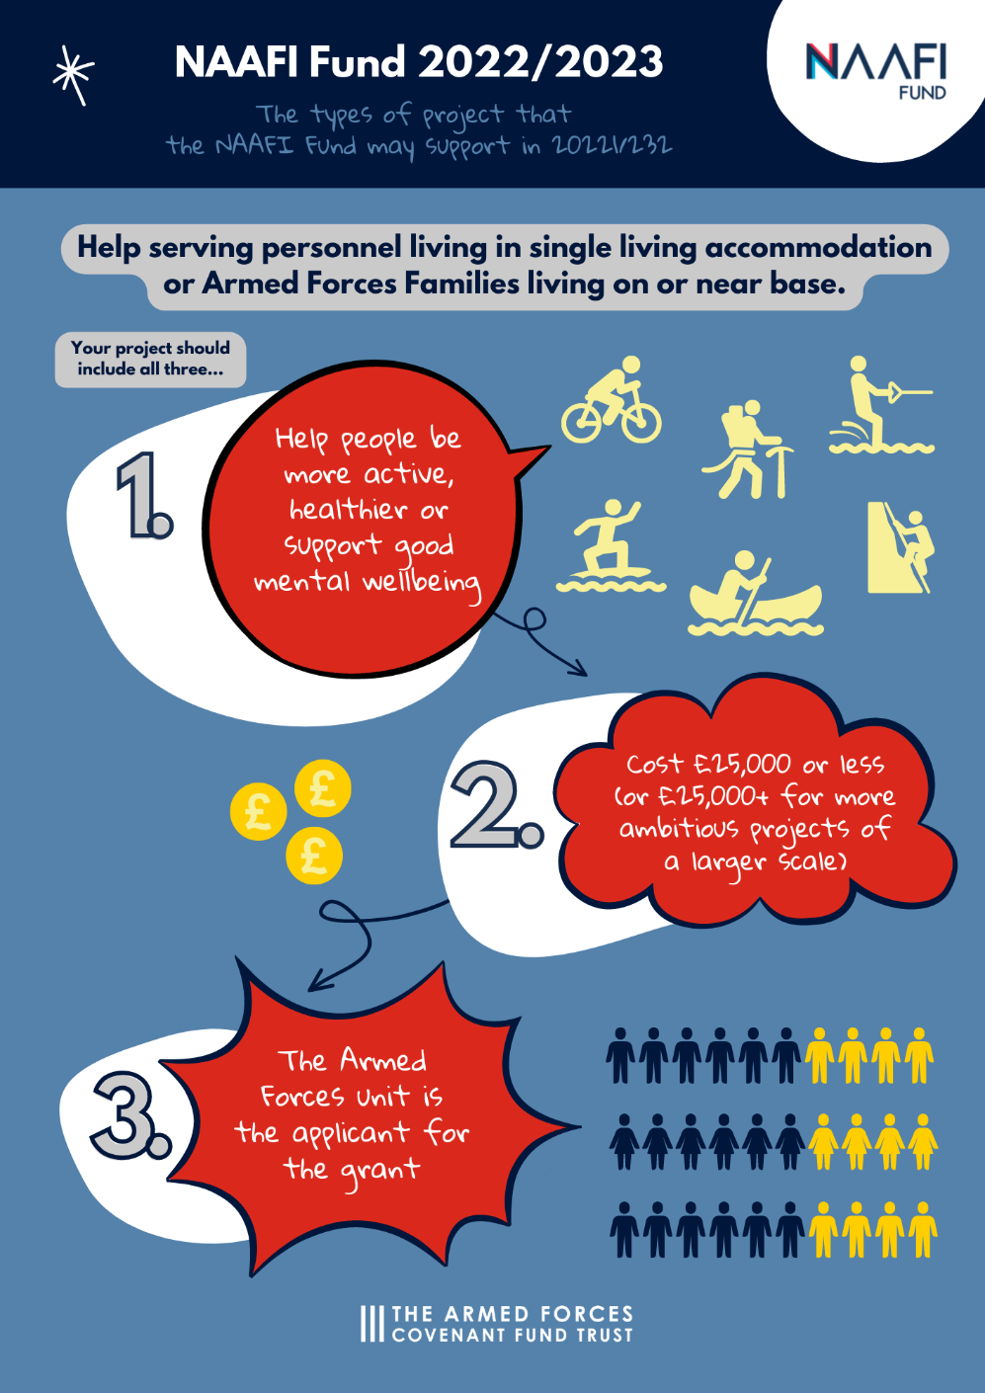

Your idea should be for a project where there is no other obvious source of funding. This means that it should not be for costs that the MOD or other funders would usually pay for, or where there is a clear, targeted funding programme that would be very likely to meet your funding needs. Your project should clearly offer support or recreation opportunities to serving personnel (and/or their families), and these activities need to take place while serving personnel are off duty.

Project ideas do not have to be new. The programme will welcome continuation or extensions of existing work where this provides a clear benefit, but you will not be able to apply for retrospective expenses. Your project cannot duplicate other similar work, and you will need to show that it offers good value for money.

If you receive a grant, we will ask you to engage with NAAFI to incorporate the NAAFI Fund in your publicity branding or signage. If we award you a grant, we will give you more information on this.

Application: Submitting your 50-word summary

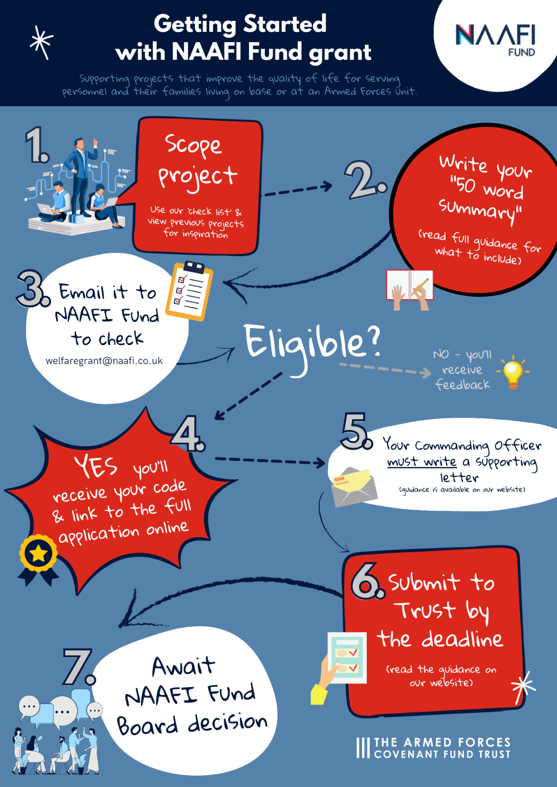

Before you submit a full application, you need to send a short (maximum 50-word) summary and an estimation of costs to NAAFI by email at welfaregrant@naafi.co.uk before 25 May 2022.

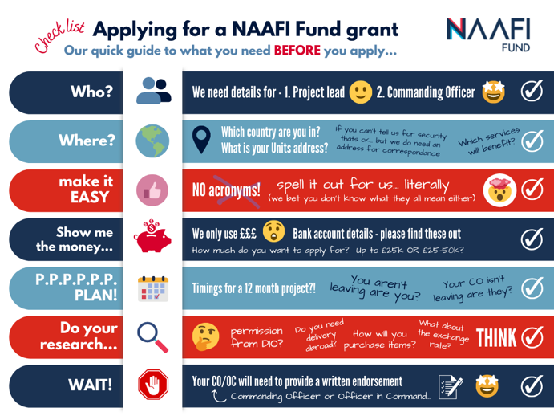
We suggest taking a look at our NAAFI ‘Step by Step Guide before you start. Here you will find further information on planning your project / completing a full application and what to expect if successful

In your email, you need to give the following information.

- The full written name of your Armed Forces unit (no acronyms).
- Your 50-word summary.
- How much funding you require to complete your project.

If your idea broadly fits with the NAAFI Fund programme, then you will be given a unique code and the link to the online application form. Your code is only valid for applications that you submit this year.

If NAAFI does not feel that your proposal is eligible – perhaps because you are seeking an amount of grant that is too large for this Fund, or outside the scope of what can be considered, they will write to advise you why and may ask you for more information. This will all need to be completed within the deadline for this stage of the funding.

No late applications will be accepted.

The code provided by NAAFI enables your application to proceed and your application is invalid without it. Your code is unique to your project idea. This means that if you make substantial changes to your idea (such as changing the focus from families to serving personnel), then you will need to write to NAAFI again for a new code.

We expect that you will make changes to the detail of your idea as you develop your application further. The application you submit must have the same, or similar summary to the project summary that you received your unique code for.

Receiving a code is no guarantee that your project will be funded.

Preparing your full application

Once you have received your code, you can complete your application using the Armed Forces Covenant Fund Trust application portal. There is more information on how to use the online application form later in this document.

As part of your application, you should tell us:

- why your project is needed
- who will benefit from it
- how you know that people will use the project
- what will happen to the project once you spend the grant funds - we would like to know how long you expect this grant to have a positive impact on your unit.

You’ll need to give us a budget for your project. We will expect you to have checked that any permissions you need to carry out your project have been obtained. If we award you a grant and your project is not able to proceed, then we will withdraw your grant.
You’ll need to make sure that you have any necessary permissions. This might be permission from DIO or from inventory holders. We need to know that if we award you a grant, the project will be able to take place. The permissions that you need may vary depending on the unit that you are serving with. Approaching staff in facilities management or equivalent may be of help.
You should also talk to your finance/ account department or the relevant budget holder at your unit. If we award you a grant, you will need to give us details of the account to pay your grant into.
You will need to include a letter from your Commanding Officer in support of your project. This letter can be uploaded as an attachment to your application. This letter should confirm that the project has their support.
Click here to find out more about project planning and letters of endorsement.
Funding will only be considered for applicants that complete both stages within the allotted deadlines.

What can funds be spent on?

Under this programme, the majority of grants awarded will be between £5,000 and £25,000. A few larger grants of £25,000 to £50,000 will be made to more ambitious projects that aim to make more substantial change.
Applications must be for projects that can be completed within 12 months of receiving a grant.
We can pay for most of the things you’ll need for your project, whether it’s people’s time, costs of delivering work online or buying/hiring equipment.
Your project might include the following costs.
- Refurbishment costs to create comfortable recreational spaces and purchasing the items that you would need for these.
- Staff time for this fixed-term project, including time-managing volunteers that may be involved in your project.
- Purchasing items that provide practical support, or that can enable activities to take place.
- Purchasing items that you may need to provide support, such as additional telephones or laptops.
- Reasonable costs for storing and transporting items, including wear and tear on private vehicles.
- Reasonable overheads that reflect the cost to your organisation of delivering this project.

You can have funding for activities that last up to 12 months, but you can also apply for projects that will take less time than this. We would expect projects that are mainly about purchasing equipment to be completed in a shorter timeframe.

You should think carefully about value for money. If you are buying equipment, consider whether it will be robust enough for your needs. The cheapest item might not offer good value if it will not last for a reasonable period of time.

It is expected that you will have a plan for how any equipment or facilities will be managed and used after the period of funding.

What can’t funds be spent on?

There are several things we can’t pay for, either because they’re not in the spirit of the NAAFI Fund, or because of relevant legislation or tax rules.

- Where funding is not benefiting people from the Armed Forces community.
- Items or costs that are the responsibility of Defence.
- Staff costs.
- Making grants or donations of money to individuals or families.
- Topping up existing grants and aid from a government department.
- Where money only benefits one person. By this we mean where your whole project would only benefit one person.
- Repeat or regular projects that require a source of uncommitted funding.
- Investments.
- Paying for ongoing costs of existing partnership activity.
- Organisational fundraising activities.
- Endowments (to provide a source of income).
- Projects, activities or services that the state has a legal obligation to provide.
- Retrospective funding for projects that have already started or taken place.
- Excessive management or professional fees or contingency costs.
- Projects that cannot define tangible benefits

This is not an exhaustive list as we feel it’s more useful to focus on what you’re trying to achieve and how you’re going about this, than to issue long lists of eligible and ineligible costs.

How to apply – full application

You need to apply using the link that NAAFI will provide in an email to you to our online Application Form. You will need the code that NAAFI will also give you in that email.

If you don’t have an account, then you will need to create one. On our system, you can save a draft application form to complete later or send a draft copy to colleagues. You can also access copies of the application that you’ve submitted at any time.

When you submit your application, you’ll receive an email confirmation. If you don’t receive this, then you have not applied.

You will need to submit your full Application by 13 June 2022

No late applications will be accepted.

We highly recommend you plan to submit your application before the deadline to avoid the risk of missing the cut-off because of technological or other unexpected problems.

You’ll receive a decision by the end of August 2022.

It’s important that we can contact you, particularly, of course, if you receive a grant. You’ll need to provide two contacts on the application, and you must use email addresses from your organisation rather than personal email addresses. At least one contact must hold the relevant authority (Commanding Officer or equivalent) to authorise the grant contract and the details of the bank account to be used should you be successful. If this is not provided, your application may be considered ineligible.

If either contact changes, after you have submitted the full Application, let us know as soon as you can by emailing info@covenantfund.org.uk

We strongly recommend that you save an offline version of your application form.

You may also find it helpful to complete your application in a Word document and then cut and paste the answers into the online form. Please don’t use any formatting, such as tables or numbered lists, in your Word document, as the online form may not accept this formatting and you might have trouble submitting the form.

We suggest you save your form every 10-15 minutes whilst you are completing it, to avoid the risk of it ‘timing out’.

Do check that you have fully answered all the questions because, if not, we might not be able to consider your application.

You do not need to send any additional information. Any additional information received will not be considered.

Do not send your application by email or post to the Armed Forces Covenant Fund Trust – only applications submitted via the online form can be considered.

There will be further rounds of funding from the NAAFI Fund. This guidance is for funding in 2022 only. More information on future funding rounds will be made available on the NAAFI Fund programme pages. You can also subscribe to our newsletter to receive updates on all funding programmes administered by the Armed Forces Covenant Fund Trust.

Our assessment criteria

Our criteria are set out below. We will consider each application to see how well it meets these criteria and fund those that we believe will best achieve the programme aims.

The difference that your project will make
What are we looking for? | That your project will achieve one or more of the following aims  - Improving quality of life for serving personnel on Armed Forces units or  - Improving quality of life for Armed Forces families living on or near the Armed Forces unit
What do you need to show us? | - What your project will do.  - How this will help.  - How you know that people would like to do this.  - How many people this is likely to help.

Delivery of your project
What are we looking for? | • | That you have the skills and experience to run your project
What do you need to show us? | • | That you have a clear plan of how you will deliver the project
 | • | That you have considered any risks
 | • | That you have the appropriate permissions that are needed to enable the project to be delivered
 | • | That your project will be good value for the money that will be spent on it

Checks we might carry out
We expect to receive more good applications than can be funded. To make sure that your project idea is not duplicating other, similar work or the same project has been approved twice, we may share details of your application with other organisations that make grants to Armed Forces units including benevolent charities and the MOD.
We will check your banking details if you are awarded a grant

Showing value for money

It’s important that your project can show good value for money.

These are some of the areas for you to consider.

- Ensuring that any equipment you wish to purchase is robust enough for its intended use (this may mean purchasing an item that is not the cheapest option, but where you can show that it is considerably more robust and will have a longer usable life).
- Ensuring that your project is not something that Defence would normally provide to serving personnel and their families.
- What will happen at the end of the project? Will any items that have been purchased continue to be used? If you have to purchase a subscription or other annually costed product; how will you sustain this in future?
- What would happen if the main contact was transferred to another posting? Who would take the project over to ensure its continuity?

Working with others

You can work with other organisations as part of your project. If any of the organisations that you will be working with will receive part of your grant, then you need to read our guidance below on delivery partners. You may, for example, wish to work with a children’s charity if you were delivering a project for Armed Forces families.

A delivery partner is an organisation which is either:

- receiving part of the grant OR
- their involvement in the project, through providing resources or some other means, is critical to the delivery of the project.

If we award you funding and you plan to work with one or more delivery partners, we will discuss with you the need to have a formal signed partnership agreement with them. You can find guidance on what a delivery partnership agreement should include on our website.

After you submit your full application

You will get an automated email to confirm that your full Application has been submitted. You should keep this and your initial NAAFI Log number for future reference.

If you have not received this email, then your application was not submitted successfully, and you will need to log back into the portal to submit it.

We will check your application to ensure that you’ve provided all the information we have requested. We may contact you during our assessment if we need any clarity or more information – but do not assume any contact or lack of contact as an indication of your likelihood of being successful or declined.

We will review the information you provide in your application.

We will assess your application against the key criteria of the programme.

Final decisions will be made by the NAAFI Fund panel, which consists of the Trustees of the Armed Forces Covenant Fund Trust and a NAAFI Non-Executive Director. The
panel will review the applications using balancing criteria in addition to the key criteria. The balancing criteria include the relative strength and value for money of the project when viewed as part of a national portfolio of projects.

Funds are limited. Therefore, the Panel use their discretion to choose which projects to fund, ensuring a good spread of funded projects and to differentiate between projects that are considered fundable.

Please note the Fund Panel may also take the decision to part-fund proposals (this may involve awarding less money than was applied for).

After the Panel have met, we will send an email to you using the primary contact email address you provided in your application. This will tell you whether you’ve been awarded a grant.
Terms and conditions of grant for the NAAFI Fund can be accessed on our website. If we offer you a grant, you will need to confirm that you will follow these terms and conditions of grant before we can release any of your grant to you.

If we plan to fund your project, you’ll need to accept our grant offer and the terms & conditions of the grant within four weeks of receiving the offer letter or risk the offer lapsing.

We will email you in the first instance to advise you that you have been successful. This email will give you full instructions of what you need to do next to receive your official offer letter, how to accept the grant and what documents you need to provide.

Please click here to find out more about what to expect if you are offered a grant

Once we have all the necessary documents back, your payments will be split based on the size of grant you have been awarded. If there are any discrepancies/queries within these documents, this will delay your payment, so please read the accompanying information we provide, thoroughly.

If you receive a grant, you will need to keep robust records of how the funds were spent, how many people you helped and how your project has helped them. We will ask you to report on this later and pay you the final amount of your grant when we have a satisfactory final report

Please click here to find out more about payments and reporting on your grant.

If we’re not able to fund your project, we will write to you to tell you this.

If you have any questions relating to this programme, please look at the programme information that we have on our website.

Following this, if you still have queries and cannot find the answer in these guidance notes, please email info@covenantfund.org.uk.

You can also visit the full NAAFI Fund Additional Step by Step guide for more information by clicking here.

When you are ready to apply, send your project summary to welfaregrant@naafi.co.uk by May 25th 2022

