Northern Hub for Veterans and Military Families Research

Pathways into Mental Health
Services for UK Veterans
March 2021

Alison K Osborne, Andrew McGill and Dr Matthew D Kiernan

Contents
Introduction 3
Methodology 4
England 5
Pathways into Mainstream NHS Mental Health Services 5
Veteran Specific Pathways into Mental Health Services 8
Wales 10
Pathways into Mainstream NHS Mental Health Services 10
Pathways into Mental Health Services through Veterans’ NHS Wales 12
Scotland 14
Pathways into Mainstream NHS Mental Health Services 14
Pathways into Mental Health Services through Veterans First Point 16
Pathways into Mental Health Services through Combat Stress 18
Northern Ireland 20
Pathways into Mainstream HSCNI Mental Health Services 20
Veteran Specific Mental Health Services in Northern Ireland 22
Pathways into Mental Health Services through The UDR & R IRISH (HS) Aftercare Service 22
Pathways into Mental Health Services through Combat Stress 25
Pathways into Mental Health Services Through Tackling Serious Stress Programme 25
Appendix A - Availability and ease of access to Mental Health Service Information for Veterans 27
Appendix B - Additional Sources of Support 30
References: 34

Introduction
Mental health care delivery for the UK population is the responsibility of the different NHS bodies in Britain and the Northern Ireland Health and Social Care Trusts. Veterans are entitled to full access to all of these services. This report outlines the pathways through which veterans can access mental health care provided by the state.
In 2017, the Ministry of Defence (MOD) published the Defence People Mental Health and Wellbeing Strategy. This five-year strategy aims to make a positive impact on the mental health care available to service personnel and military veterans. The Strategy states that the MOD will continue to work in partnership with the health services and the third sector in order to promote veteran specific mental health services. However, health is a devolved matter in the UK and mental health service provision varies across each nation (House of Commons, 2018). This variation affects the services available to veterans. The aim of this report is to detail the primary pathways into mental health services for veterans across the UK.
The content of this report has been reviewed for accuracy and cleared for publication by NHS England, Scottish Veterans and Armed Forces Personnel Unit, Welsh Government Armed Forces Covenant Team and Northern Ireland Veterans’ Support Office.

Methodology
This report provides details of the statutory provision of mental health care, which is funded by the NHS or devolved Governments. The exception to this is Northern Ireland where the MOD and the third sector would appear to provide a significant proportion of services. The report shows the pathways into ‘mainstream’ mental health services that are available to veterans and the civilian population, and the primary pathways into veteran specific services across the UK.
There were three stages involved in the production of this report, as follows:
Stage 1: The method used to produce the initial draft involved a comprehensive online search for publicly available information about the pathways into mental health services for veterans across the UK. This was undertaken to determine how accessible the information on mental health services was to veterans and military families.
Stage 2: On completion of Stage 1, the initial findings were reviewed using semi-structured interviews with subject matter experts (SME’s) and representatives from each home nation; England, Scotland, Wales and Northern Ireland. The semi-structured interviews were recorded and transcribed verbatim. SME’s were asked to review drafts for accuracy and to make any necessary amendments.
Stage 3: The third stage offered the opportunity to approve the final draft. SME’s were asked to provide consent for publication of this report once all amendments were accepted.
Pathways into mainstream mental health services and veteran specific services are described in this report under the heading of each of the four nations, England, Wales, Scotland and Northern Ireland.

England

Pathways into Mainstream NHS Mental Health Services
Five primary pathways into mental health services are available to the general population as part of mainstream service provision in England:
- General Practice (including Out of Hours)
- Urgent/Emergency Care
- Self-Referral into Primary Care or Improving Access to Psychological Therapies (IAPT)
- Referral into a Crisis (and Home) Intervention Teams
- Referral into a Substance Misuse Service

Figure 1. Illustrates the pathways into mainstream mental health service in England.
For veterans who present with mild to moderate mental health related needs, a referral (including self-referral) can be made for treatment within community-based services. An example of this is the Improving Access to Psychological Therapies (IAPT), which accept both self-referral and referral from General Practitioners (GPs). Recent evidence from the Map of Need Project conducted by the Northern Hub for Veterans and Military Families Research at Northumbria University, demonstrates that veterans frequently access IAPT services at similar population adjusted rates to those of the general population.
Veterans with more complex needs may be referred, either by voluntary admission, or under a section of the Mental Health Act, for assessment and treatment within inpatient services delivered within a secondary care or hospital setting,
Veterans presenting at a GP surgery, an emergency service unit or NHS mental health care services with a long-term mental health condition may be referred to a community mental health team to receive ongoing care and support. The community mental health team can make referrals to wider mental health services as required (i.e. inpatient and outpatient services) and have the option to make referrals to assertive outreach teams (also known as crisis teams or home care). Assertive outreach teams are specialist mental health services, which provide personalised, holistic, long-term support to those with particularly complex needs and liaise with organisations across the whole of the health and social care sector.
NHS crisis intervention teams are also part of mainstream mental health service provision in England and can support veterans who are in crisis in the community. Services provided by Crisis Intervention Teams are reserved for cases which meet a strict definition of crisis, which typically involves a risk to the life of the service user or others.
Statutory mental health services in England are planned for and funded by c200 local Clinical Commissioning Groups (CCGs).
In accordance with the England Health and Social Care Act (2012), public health provision is the responsibility of local authorities in England. Therefore, Veterans who present within any of the mainstream NHS health services included within Figure 1 may be referred to local authority led substance misuse services for treatment (with detoxification treatment provided by NHS England). Some alcohol and substance misuse services also accept self-referrals.

Figure 1. Pathways into Mainstream NHS Mental Health Services in England
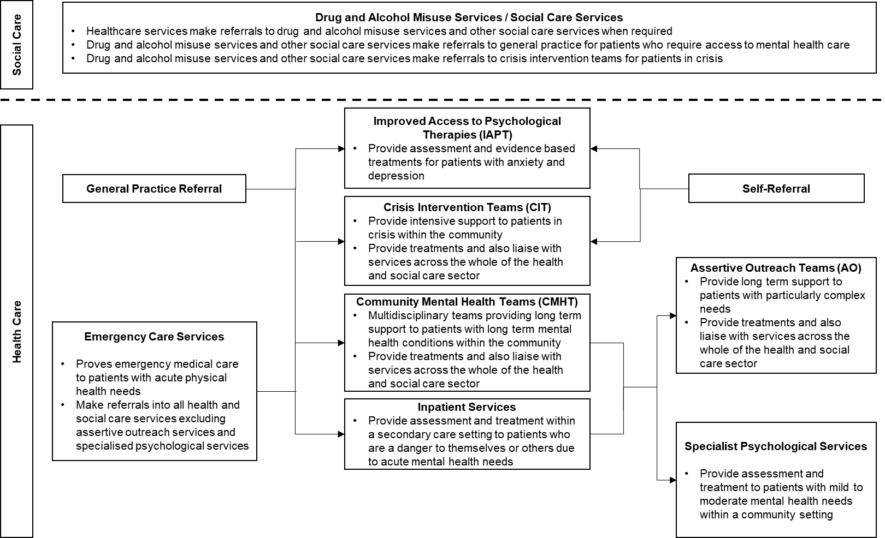

Veteran Specific Pathways into Mental Health Services
In addition to mainstream services, Veterans in England have access to a national helpline provided by Combat Stress and an integrated, multi-service, veteran specific, mental health and wellbeing model of care, funded nationally by NHS England – NHS England and NHS Improvement Op COURAGE: The Veterans Mental Health and Wellbeing Service. The three services are:
- Service 1: Veterans’ Mental Health Transition, Intervention and Liaison Service (TILS)
- Service 2: NHS Veterans’ Mental Health Complex Treatment Service (CTS).
- Service 3: including NHS Veterans’ Mental Health High Intensity Services (HIS).
Figure 2. illustrates the pathways into mental health services through the NHS England Transition, Intervention and Liaison Service (TILS). TILS is particularly suitable for veterans who require specialised and/or veteran specific care. Veterans accessing any mainstream services or visiting welfare organisations can be referred into TILS and TILS also accept self-referrals from veterans across England.
TILS consists of a specialist ‘military aware’ team, who are able to provide veterans with a general needs assessment and a clinical assessment in order to assess their psycho-social needs and develop personalised care plan. This care plan facilitates ongoing case management and suitable liaison.
In order to facilitate care plans, TILS may provide treatment internally, or may provide onward referrals to a wide range of services, mainstream NHS services, veteran specific third sector organisations, local authority drug and alcohol services and other social care organisations.
For veterans who are in a mental health crisis and need urgent and emergency care and treatment HIS provides liaison, advice and support for health and care services close to veterans’ own homes should they be experiencing a mental health crisis and, following that, provide support for veterans to gain stability in their lives including some support for families.
If the treatment needed cannot be provided by mainstream services through TILS or HIS, they may be referred to NHS Veterans’ Mental Health Complex Treatment Service (CTS). CTS provides intensive care and treatment for veterans with complex mental health problems that have not improved with earlier care and treatment.

Figure 2. Pathway into Mental Health Services through the Veterans’ Mental Health Transition, Intervention and Liaison Service and NHS Veterans’ Mental Health High Intensity Services
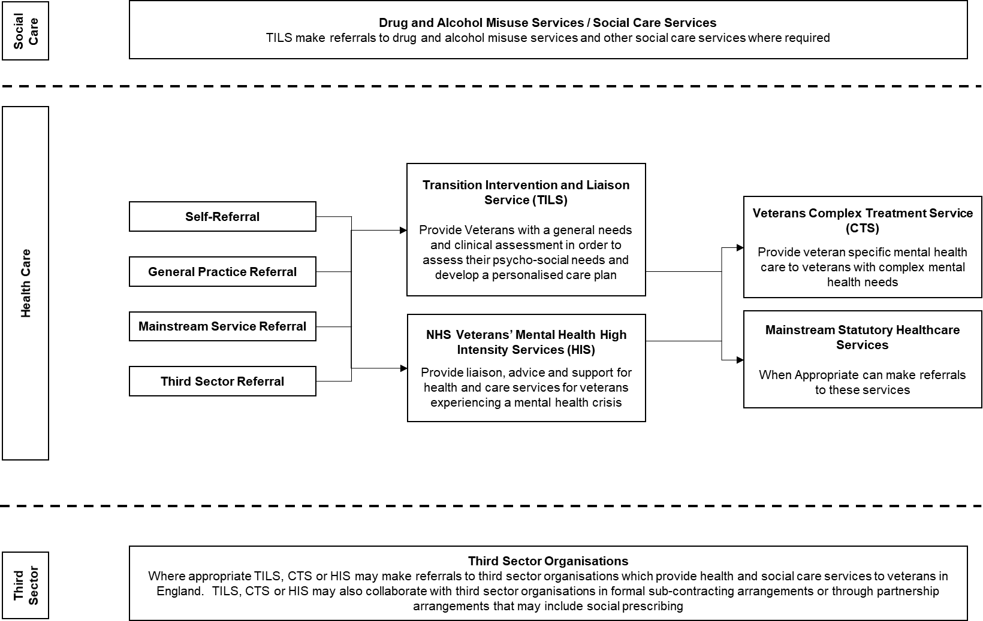

Wales

Pathways into Mainstream NHS Mental Health Services
Health services in Wales are devolved and, whilst pathways into mainstream statutory mental health services in Wales largely mirror those in England (see Figure 1.), there is some key variation in the provision of specific services. Figure 3. illustrates the pathway into mainstream NHS services for veterans in Wales.
In 2010, the Welsh Government introduced the Mental Health (Wales) Measure making Local Health Board and Local Authorities legally responsible for providing care and support to individuals with mental health related needs. Seven Local Health Boards determine the provision of mental health services across Wales. As such, service provision varies across each Local Health Board area, in order to meet the needs of the local population.
In Wales, each health board is responsible for providing specialist low-intensity psychological services. Many of these services accept self-referrals, as well as GP referrals. This is the equivalent provision to the IAPT service in England.
Local primary mental health support services are in place under the Mental Health (Wales) Measure 2010, These provide access to primary care level mental health interventions for anyone requiring support through referral from GP. Primary mental health support services also offer a wider range of brief interventions under the Matrics Cymru guidance to support greater quality and consistency in the delivery of psychological therapy across Wales. These interventions are aimed at mild/moderate mental health problems. They include:
- Psychologically informed solution focused interventions to increase activity and social engagement
- Guided self-help for specific mental health related distress
- Supported Computerised CBT (CCBT) and Telephone CBT (TCBT)
- Structured psycho-educational groups with an evidence base for a variety of common mental health problems/distress e.g., anxiety management/sleep/depression
- Structured exercise referral scheme.
All Local Heath Boards in Wales provide crisis care services. The structure of services varies within each health board. Community Mental Health Teams and, in most cases, Home Treatment Teams fulfil an Assertive Outreach function.

Figure 3. Pathways into Mainstream NHS Mental Health Services in Wales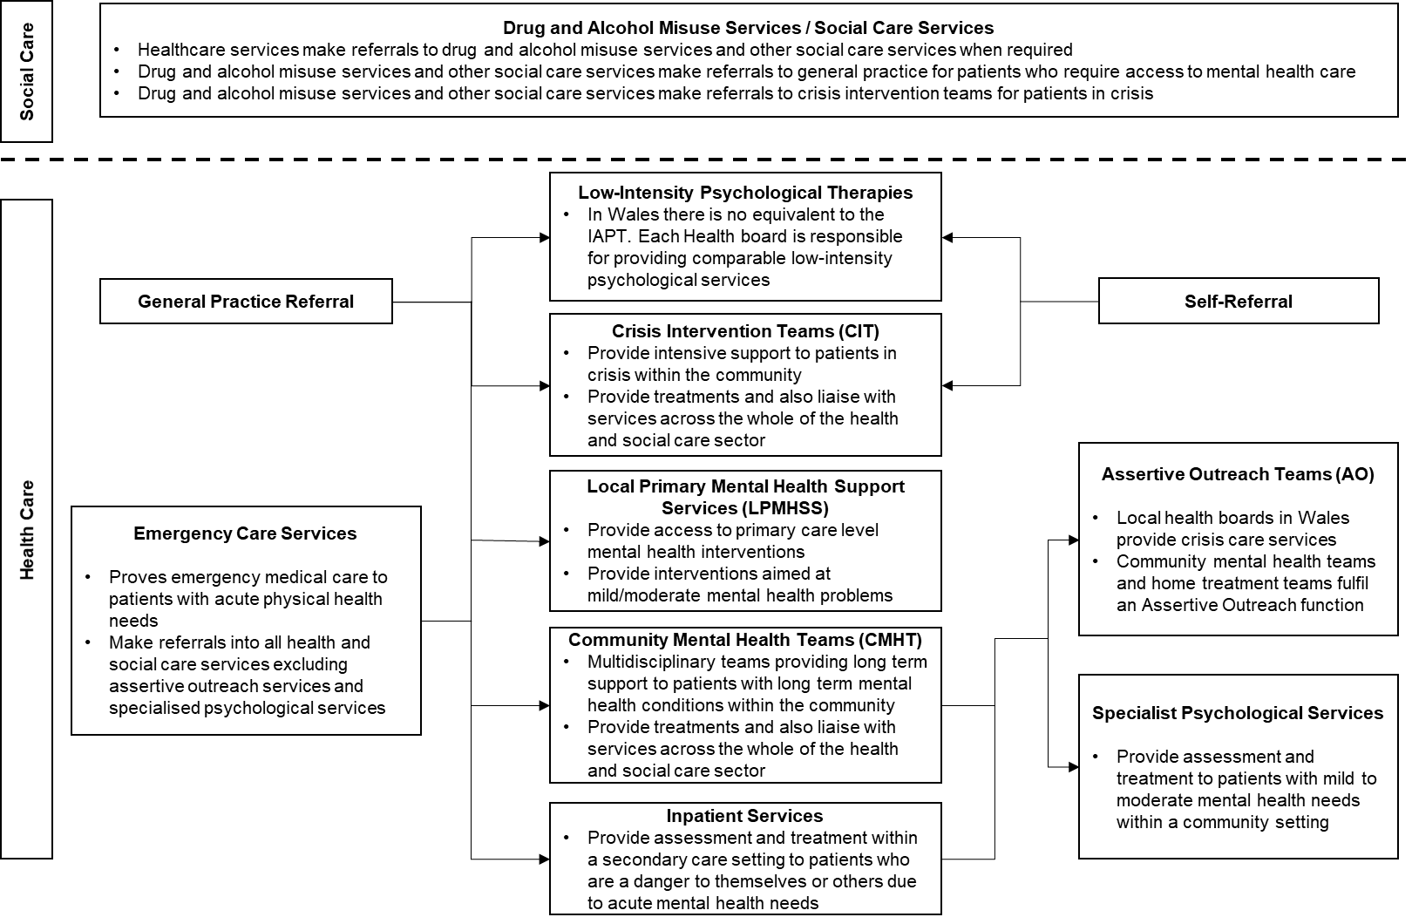

Pathways into Mental Health Services through Veterans’ NHS Wales
In addition to mainstream services, veterans in Wales also have access to statutory funded veteran specific mental health services. Veterans’ NHS Wales offers a Wales wide NHS outpatient service for veterans with service-related mental health problems.
Referrals to VNHSW arrive via several routes, including primary care, self-referral, and various veterans’ charities/agencies e.g., RBL, SSAFA, Veterans UK and Change Step.
Figure 4. illustrates the pathway into Veterans’ NHS Wales. Following a referral to Veterans’ NHS Wales, a clinical assessment is carried out at a suitable location or by telephone. Therapists (who are either veterans themselves or have expert knowledge of working with the Armed Forces) are able to provide care for veterans with mild to moderate mental health needs, using evidenced-based, psychological interventions, over 16-20 out-patient sessions.
Where required, Veterans’ NHS Wales also work closely with partner agencies in order to support the veteran to address a range of health and social care related needs.
Veterans who present with more complex needs, or non-service attributable needs, will be referred for treatment within the most appropriate mainstream NHS mental health services.
For veterans who present with drug and/or alcohol dependencies, referrals may be made to NHS or Local Authority substance misuse services. On successful completion of substance misuse treatment, it is possible to make a ‘fast track’ referral to Veterans NHS Wales

Figure 4. Pathway into Mental Health Services through Veterans’ NHS Wales
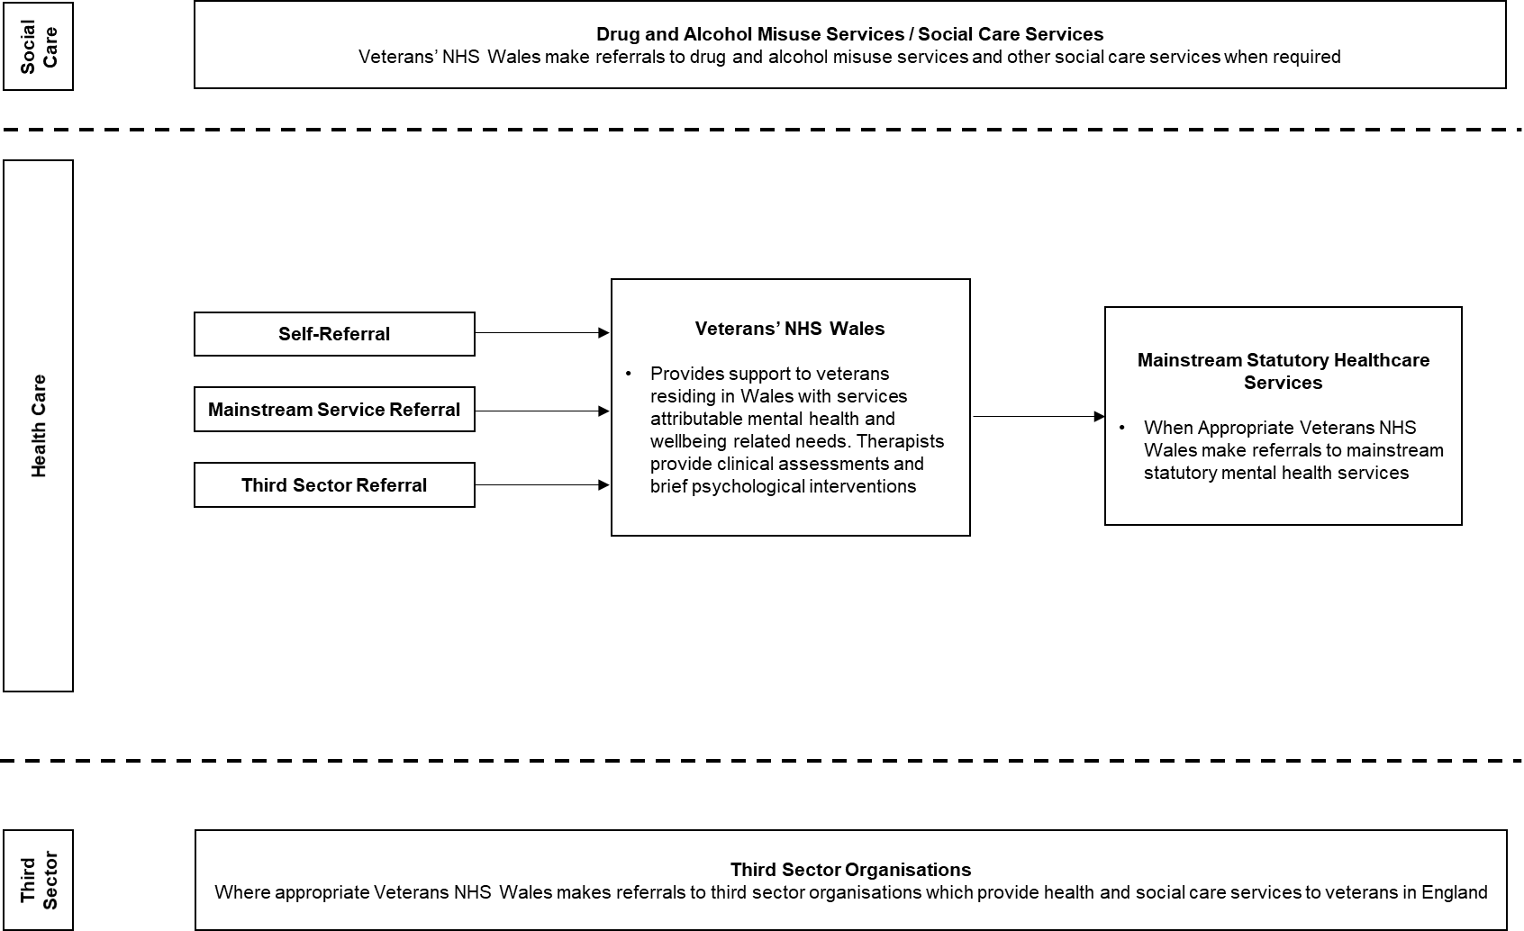

Scotland

Pathways into Mainstream NHS Mental Health Services
Pathways into mainstream NHS services in Scotland largely mirror those in England (see Figure 1.). However, there are some key variations in the provision of specific services in Scotland. Figure 5. illustrates the pathways into mainstream NHS mental health services on Scotland.
In some areas of Scotland, some of the functions of Community Mental Health Teams, such as intensive home treatment is managed by other services. Bespoke intensive home treatment (IHT) services provide urgent mental health assessments, treatment and risk management in a community setting to individuals with acute mental health related needs.
Assertive Outreach teams do not operate across all areas in Scotland. In areas without Assertive Outreach teams, comparable support is provided by Community Mental Health Teams.
In Lanarkshire, Borders, Aberdeen and the Highlands, a 53-month pilot is providing patients, who present in distress at emergency services and community care settings with access to a Distress Brief Intervention (DBI) programme within 24 hours. The DBI approach emerged from the Scottish Government’s work on Suicide Prevention and Mental Health strategies. The model for the delivery of DBI includes a two-week, two-tier intervention. DBI Tier 1 is provided by frontline staff and includes signposting and the option of referrals to DBI Tier 2. DBI Tier 2 is provided by specialised third sector staff and includes a range of community-based wellbeing support, signposting and supported connections.
In accordance with Action 15 of the Scottish Government’s 2017-2027 Mental Health Strategy, additional funding supports local services by investing in 800 additional mental health professionals working in variety of settings (accident and emergency departments, GP practices, police custody suites and prison services) by 2021/22.

Figure 5. Pathways into Mainstream NHS Mental Health Services in Scotland
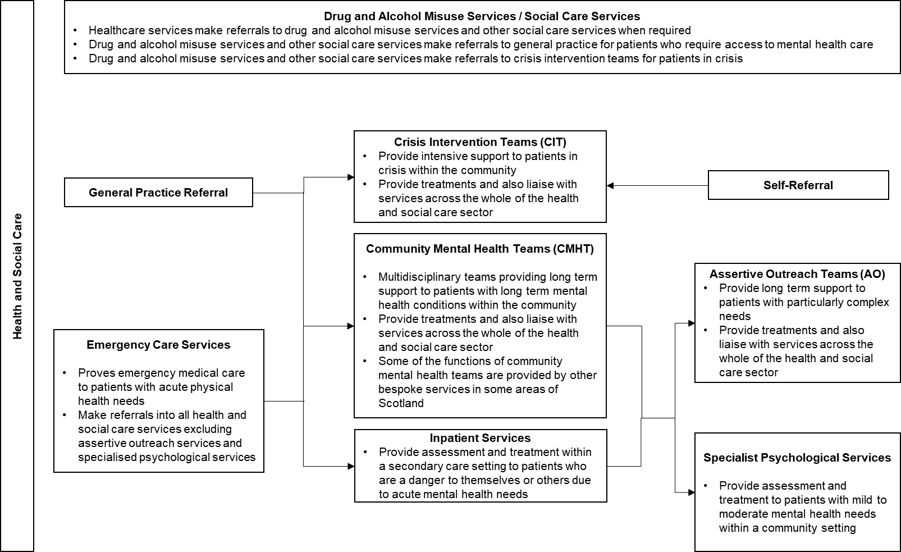

Pathways into Mental Health Services through Veterans First Point
In addition to mainstream services, veterans in Scotland have access to two veteran specific services as part of statutory care delivery. Figure 5. illustrates the pathway into mental health services through Veterans First Point (V1P).
V1P was established in 2009 by NHS Scotland in order to provide holistic support to veterans across Scotland no matter their needs, including health, welfare, housing, and employment. The NHS led V1P network operates as both a treatment provider and liaison service. Veterans may be offered treatment on site or may be referred/sign-posted to mainstream NHS services, Combat Stress services, veteran specific third sector organisations, drug and alcohol services or other social care organisations.
Veterans First Point (V1P) Scotland is a network of six regional centres across Scotland (see Figure 1), providing a holistic veteran-led mental health and welfare support service for veterans. These centres are provided by local Health and Social Care Partnerships, covering just under half of all Health Board areas. In areas without access to V1P services, veterans’ mental health needs are managed by mainstream NHS services.
V1P Scotland aims to maximise engagement with Scottish veterans and support their recovery through provision of a veteran-led service providing welfare and psychological support. V1P Scotland aims to address the needs of Scotland’s veterans through provision of a veteran designed service that acknowledges the unique profile and needs of veterans as a group. By basing the V1P Scotland service model on the expressed needs of Scottish veterans who had experience of accessing mainstream mental health services, the network has strived to deliver a service that is acceptable to veterans through being accessible, co-ordinated, and credible. The employment of experienced veteran Peer Support Workers across V1P Scotland, who provide essential welfare and life support to service users, ensures the service continues to be veteran-led in its approach.
In March 2017, the original LIBOR funding for this service ended. In September 2017 Scottish Government agreed to provide match funding until 2020 to support the established services. Until March 2020, the Scottish Government also fund a central V1P team who play a lead role in influencing and supporting local areas to make longer term decisions on the future of the V1P service.

Figure 6. Access to Veterans First Point.
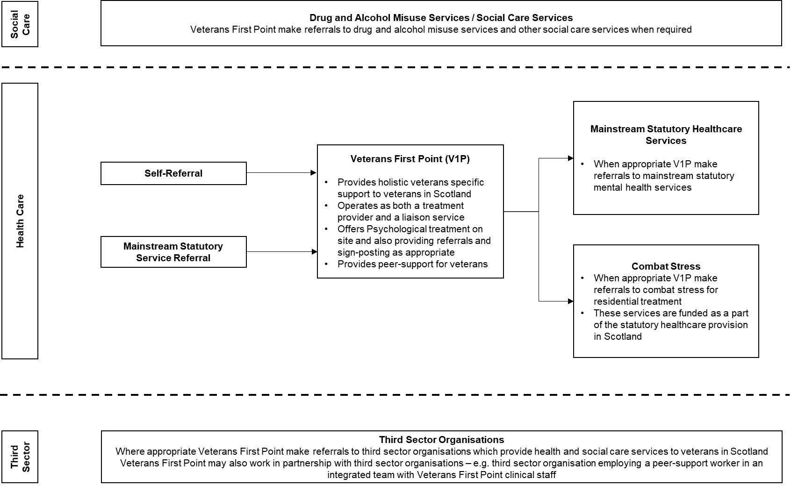

Pathways into Mental Health Services through Combat Stress
In Scotland, the Scottish Government has allocated £1.4m per annum to Combat Stress to provide community and residential treatment to Scottish Veterans. The contract, which runs from April 2018 to April 2021, is managed by NHS Ayrshire & Arran on behalf of the Scottish Government.
Figure 7. illustrates the pathway into mental health services through Combat Stress pathway. Following for veterans in Scotland.
Veterans can self-refer into Combat Stress using the 24/7 Combat Stress helpline. Professionals can also refer in using the referral form on the website. Veterans are invited to complete some psychometric information about their current mental health and these referrals are then screened by a senior clinician. Following this screening process, veterans are offered a Full Clinical Assessment, undertaken by a nurse, occupational therapist or psychologist. The results of the assessment are then discussed at an interdisciplinary meeting and a recommendation made for the care and treatment of the veteran.
This could be treatment provided by Combat Stress – in the community or residential. Alternatively, veterans may be signposted to other organisations providing mental health support (such as a local community mental health or substance misuse services) – both statutory and third sector - or referred back to their GP if Combat Stress is unable to help (see Figure 5. for the pathways into mainstream mental health services in Scotland).

Figure 7. Access to Combat Stress for veterans in Scotland.
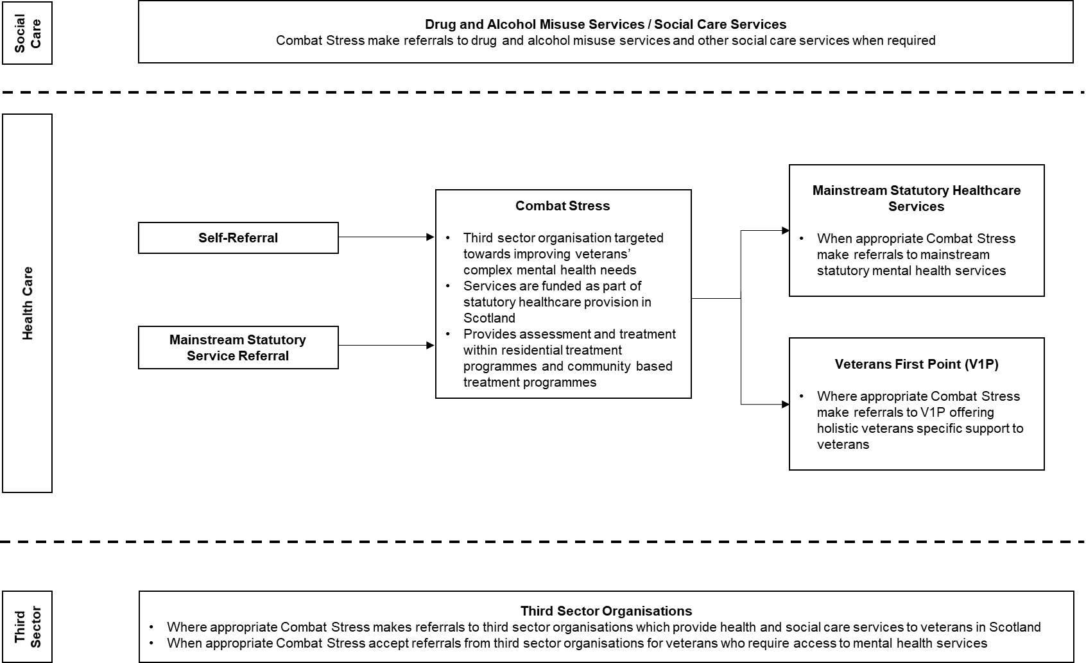

Northern Ireland

Pathways into Mainstream HSCNI Mental Health Services
Pathways into mainstream mental health services in Northern Ireland largely mirror those in England. However, in Northern Ireland, five regional Health and Social Care Trusts including Belfast, Northern Trust, South Eastern, Southern Trust and the Western Trust and the Northern Ireland Ambulance Service Trust (collectively referred to as Health and Social Care Northern Ireland, HSCNI) are responsible for both health and social care provision. In Northern Ireland, HSCNI is equivalent to the NHS in England, Wales and Scotland.
Each of the regional HSCNI Trusts has a local Commissioning Board. While all localities commission community-based care and specialist mental health services, the specific nature of service provision varies across Northern Ireland. For example, Belfast HSC Trust provide specialised multi-disciplinary treatment to adults affected by the Troubles within the Trauma Resource Centre at the Everton Complex, while Southern HSC Trust provide specialised support and counselling to adults affected by the Troubles within the Trauma Counselling Service.
In Northern Ireland, Crisis Intervention Teams do not accept self-referrals and is actioned through GP services.
Bespoke assertive outreach teams do not operate in Northern Ireland. The function of assertive outreach is provided by Community Mental health Teams and Home Treatment Teams.

Figure 8. Pathways into Mainstream HSCNI Mental Health Services in Northern Ireland
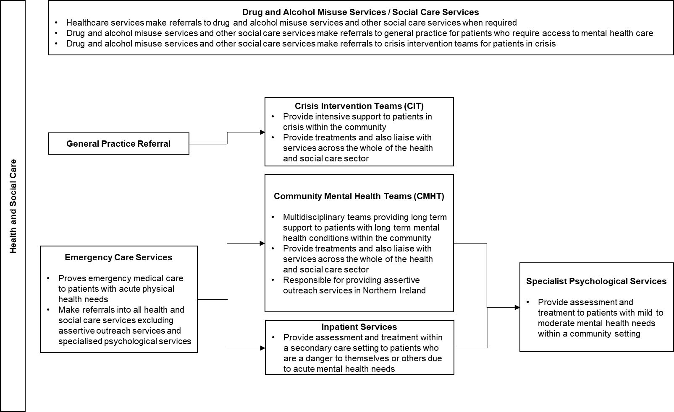

Veteran Specific Mental Health Services in Northern Ireland
Within the unique historical, political and social context of Northern Ireland, many veterans are reluctant to reveal their service history, due to security concerns (Armour et al., 2018; Forces in Mind Trust, 2017). As a result, a direct pathway into mainstream statutory services is often perceived to be inaccessible.
The statutory provision of veteran specific mental health services in Northern Ireland is currently limited to services provided by The UDR and Royal Irish (HS) Aftercare Service and is subject to strict eligibility criteria.

Pathways into Mental Health Services through The UDR & R IRISH (HS) Aftercare Service
Figure 9. illustrates the pathway into Mental Health Services through The UDR & R IRISH (HS) Aftercare Service (referred to as ACS hereafter).
ACS was introduced in 2007 by the MOD, as part of a wider strategy to enhance the support available to veterans of The Ulster Defence Regiment and The Royal Irish Regiment (Home Service) on disbandment at the end of Operation BANNER. The primary aim of ACS is to provide bespoke holistic welfare support, including medical treatment and mental health care for conditions caused by or aggravated by service. Additionally, the service aims to bridge the gap between the third sector and statutory mental health services, encouraging and supporting reluctant veterans to engage in statutory mental health services when necessary.
Those eligible for direct support are all former Full Time and Part Time UDR and R IRISH (HS) soldiers and their dependants. A scheme also exists to assist other veterans recently discharged from the Army as Wounded, ill, or Sick and resident in Northern Ireland, however the core client base remains the Regimental family.
Following a referral from whatever source, including self, to ACS, a caseworker will conduct a home visit to complete a needs assessment. Veterans with mental health related needs will be referred for a clinical assessment and treatment within Inspire. Inspire is a not-for-profit organisation contracted by the MOD to work with ACS and offers brief psychological interventions for mild to moderate mental health disorders. Veterans with more complex needs can also be referred to an Inspire Psychiatric Consultant.
Following a course of treatment, Inspire provide a treatment report to the veteran’s ACS welfare caseworker and their local HSCNI General Practice. Where appropriate, the caseworker may encourage and support veterans to visit General Practice in order to access mainstream HSCNI services (see Figure 8. For the pathways into Mainstream HSCNI Mental Health Services in Northern Ireland) or provide signposting to veteran specific third sector organisations.
Where suitable, veterans who are found to co-present with alcohol or substance misuse, will be offered a referral for rehabilitation treatment within Addictions NI, prior to accessing mental health treatment with Inspire.
Defined within the contractual agreement between the MOD and Inspire are strict eligibility criteria which currently limit the availability of ACS and Inspire services to specific groups of veterans within Northern Ireland. Treatment within Inspire via ACS is only available to veterans of the Royal Irish Regiment (Home Service) or the Ulster Defence Regiment with service attributable needs. However, a pilot scheme extended the availability of the Aftercare Service to include all veterans within Northern Ireland discharged as Wounded, Injured or Sick (WIS) via the MOD Personnel Recovery Unit. To date, a small number of WIS veterans (<200) have engaged with ACS, and 18 have received psychological treatment through Inspire.

Figure 9. Pathway into Mental Health Services through The UDR & R IRISH (HS) Aftercare Service
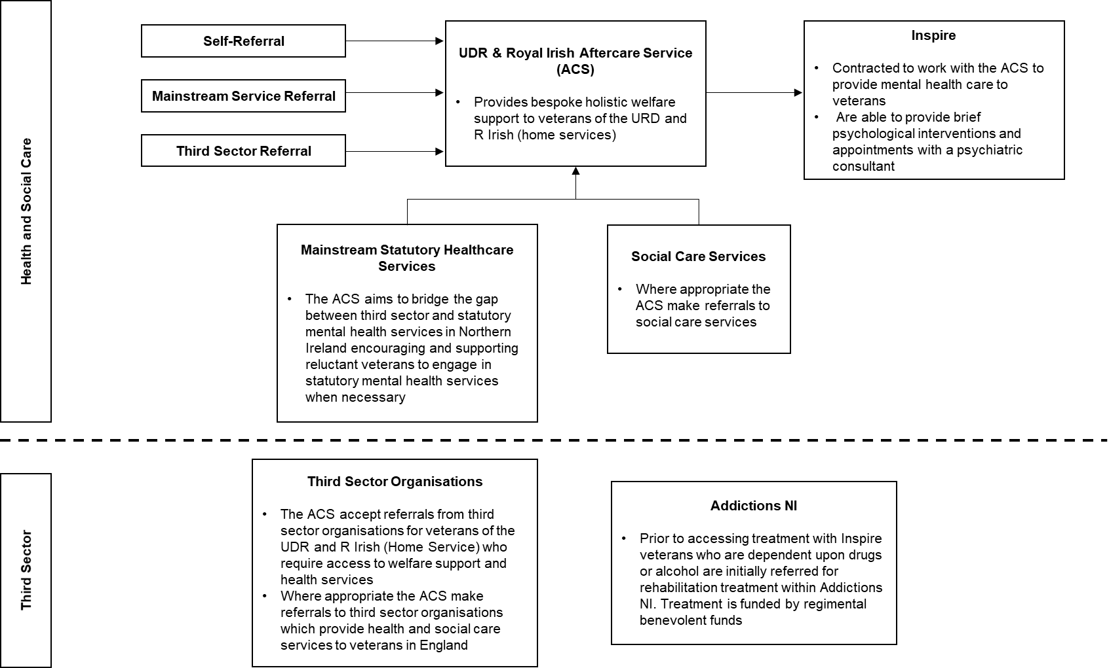

Pathways into Mental Health Services through Combat Stress
Figure 10. illustrates the pathways into Combat Stress for veterans in Northern Ireland. Combat Stress do not receive statutory funding from Northern Irish Government for the provision of treatments for veterans residing in Northern Ireland. However, data from the Map of Need project, conducted by Northumbria University’s Northern Hub for Veterans and Military Families Research) would suggest that Combat Stress is a significant provider of mental health care for veterans in Northern Ireland. Furthermore, Northern Ireland has the highest Combat Stress patient rate (referrals per 10,000 of population) of all the home nations.
The pathways into treatment provided by Combat Stress in Northern Ireland largely mirror those in Scotland (see Figure 7. for the pathway into mental health services through Comat Stress in Scotland). However, in Northern Ireland, veterans who present within Combat Stress services with alcohol or drug dependencies are advised to visit their GP in order to be referred to HSCNI alcohol and substance misuse services.

Pathways into Mental Health Services Through Tackling Serious Stress Programme
A significant provision of non-statutory veteran specific mental health support in Northern Ireland is delivered through the Armed Forces Covenant Fund Trust funded Tackling Serious Stress programme. Two organisations – Inspire Wellbeing and Brooke House - deliver the programme. Inspire Wellbeing deliver the ‘Recovery Together’ Programme throughout Northern Ireland which prioritises a ‘whole family approach’. It recognises that the challenges faced by the individual will impact upon the wider family, and therefore aims to support and strengthen the family unit, agreeing on and moving towards goals at each stage of the recovery process.
This is enhanced in the largely rural counties of Fermanagh, Armagh and Tyrone by the Brooke House element of Tackling Serious Stress Programme where, after an initial screening appointment, clients are referred to a range of different services, support programmes and interventions as appropriate, which include Psychological Support, a structured residential programme, physiotherapy, complementary therapy, nature-based therapy, physical activity or Defence Gardens’ Scheme programmes.
In both cases, clients can self-refer or be referred by Statutory Services, the Community and Voluntary Sector or Armed Forces Charities and Associations. In both cases, clients will be supported and reviewed by a Case Manager or Health and Wellbeing Coordinator.

Figure 10. Pathway into Mental Health Services through Combat Stress
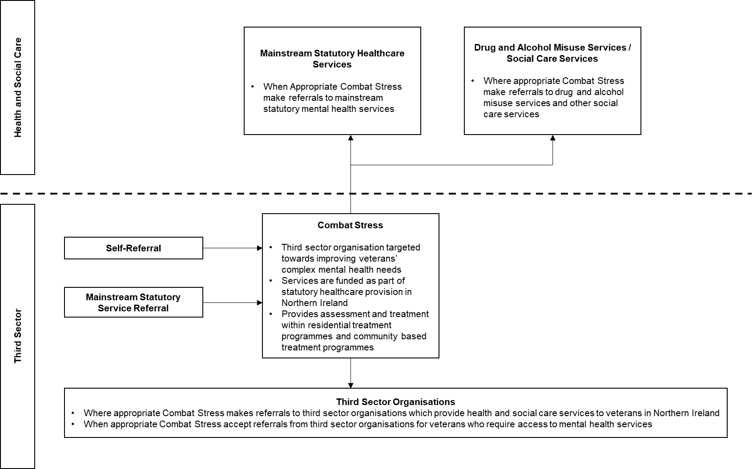

Appendix A - Availability and ease of access to Mental Health Service Information for Veterans
The initial process involved in the production of this report was an extensive online search for publicly available information. This appendix details the researcher’s subjective view of how easily this information was to attain.
England
NHS England provide an extensive body of publicly available information about mainstream statutory mental health services in England through the NHS website (www.nhs.uk). Information about various services and referral pathways can be found by using the search function on the NHS website. However, based around the initial internet search, the pathways between services in England were unclear.
NHS England also provide information through the ‘Services for Members of the Armed Forces’ section of the website (and the ‘Veterans: NHS Mental Health Services’ section via www.nhs.uk/using-the-nhs/military-healthcare/nhs-mental-health-services-for-veterans/). The information provided includes details of referral pathways and some indication of the pathways between services.
Wales
NHS Wales provide an extensive body of information about mainstream statutory mental health services in Wales through the ‘Mental health Service’s section of the NHS Direct Wales website. Additionally, NHS Wales and Welsh Government provide information on the 2010 Mental Health (Wales) Measure and the Together for Mental Health strategy through the ‘Mental Health’ section of the NHS Wales website and the ‘Mental Health’ section of the Welsh Government website. However, based upon the initial internet search, it was not possible to identify the pathways between services in Wales.
NHS Wales also provide information about veteran specific mental health services through the dedicated Veterans’ NHS Wales website (www.veteranswales.co.uk/). The information provided includes clear details of referral pathways, details of the veteran specific treatments provided by Veterans’ NHS Wales and an indication of the pathways between Veterans’ NHS Wales and other services.
Welsh Government provide information about veteran specific mental health services through the Welsh Government website (https://gov.wales/topics/health/nhswales/mental-health-services/policy/veterans/?lang=en). The information provided includes details of the veteran specific care provided by health boards in Wales. There is no information about referral pathways into veteran specific mental health care in Wales, however the website includes a URL link to the Veterans’ NHS Wales website, which provides this information.
Scotland
NHS Scotland provide an extensive body of information about mainstream Scottish mental health services through the Mental Health and Wellbeing section of the Health Scotland website (www.healthscotland.scot/health-topics/mental-health-and-wellbeing). However, based upon the initial internet search, it was not possible to identify the pathways between services in Scotland.
Scottish Government provide information about veteran specific statutory mental health services through the ‘Veterans Health’ section of the MyGov website (www.mygov.scot/veterans-health/) and also include a URL link to a page which outlines Scottish Government's healthcare objectives for veterans. Information is provided for healthcare support through both Veterans First Point and Combat Stress.
Northern Ireland
Each HSCNI Trust in Northern Ireland host an individual website, through which they provide information about available services. Based upon the initial internet search, it was evident that the structure of mental health service provision in Northern Ireland varies significantly from other areas of the UK. The breath of publicly available information provided on each of the trust’s websites varies, however it is generally limited to a brief description of available services and referral information. Based upon the initial internet search, the pathways between services in Northern Ireland were unclear. Furthermore, due to the lack of co-ordinated information on mental health service provision across Northern Ireland as a whole, the standard structure of mainstream statutory mental health service provision was unclear based upon the initial internet search.
There are no mentions of veteran specific mental health care provision on any HSCNI trust website and the website does not offer any information about the most appropriate mental health services for veterans in Northern Ireland.
The UDR and Royal Irish (HS) Aftercare Service host a dedicated website which provides brief information about available services. However, the pathways into other mental health services through the Aftercare Service were unclear based upon the information provided. Furthermore, this website did not appear to have strong representation within popular web-search platforms such as Google Search or Bing. As such, this website may be difficult to accessed for anyone with no prior knowledge of the service.
The initial internet-based search did not reveal any information which would indicate that Combat Stress provide a significant proportion of the mental health care for veterans in Northern Ireland without receiving any statutory funding.

Appendix B - Additional Sources of Support
The service pathways included within this report represent the primary pathways into mental health services for veterans across the UK. Veterans are also able to access alternative forms of support. Examples are provided below.
United Kingdom
NHS Mobile Applications Library
Website: https://apps.beta.nhs.uk/category/mental_health/
Mobile applications which promote the successful management of mental health disorders are listed in the NHS applications library under the Mental Health category. Some applications are free for use while others are provided at a price to the user. Some applications are openly accessible, while others require a prescription from a primary care mental health professional.
Social Prescribing
Across the whole of the UK, GP’s, nurses and all other primary care professionals are able to refer patients to local, non-clinical services. Social prescribing is designed to address a wide range of social, emotional and practical needs, using a holistic, person centred approach and to support self-management amongst patients with mild to moderate mental health disorders.
Veterans’ Gateway
Freephone Line: 0808 802 1212 (Monday – Sunday, 24 hours) or text: 81212
Live Chat/Email Support: www.support.veteransgateway.org.uk
Website: www.veteransgateway.org.uk
Veterans’ Gateway consists of a consortium of organisations and Armed Forces charities, including The Royal British Legion, SSAFA – the Armed Forces charity, Poppyscotland, Combat Stress and Connect Assist. Veterans’ Gateway are connected with a range of key referral partners and information organisations – both within and outside the Armed Forces sector – and are able to assist veterans in accessing appropriate support through their freephone, text and webchat services.
The Veterans and Families Directory of Services
Website: https://www.veteransgateway.org.uk/local-support/
The Veterans and Families’ Directory of Services (VFDS) within the Veterans Gateway Website provides a UK wide map of third sector organisations, local services and national services which provide support to UK military veterans and their families. Services are grouped into categories that include Mental Health Services and Emotional Support. Veterans and service providers may use the VFDS to identify local mental health services and support for veterans.
Combat Stress
Freephone 0800 138 1619 (24 hours a day, 7 days a week), or text 07537 404 719
Email: helpline@combatstress.org.uk
Combat Stress are the UK’s leading third sector mental health organisation for veterans and provide veterans and their families with advice and support through a range of clinical, community based and residential mental health services.
Samaritans
Freephone: 116 123 from any phone (24 hours a day, 7 days a week)
Email Support: jo@samaritans.org
Website: www.samaritans.org
Samaritans provide a national helpline that offers confidential, emotional support to anyone experiencing feelings of distress or despair, including those that may lead to suicide. Face-to-face meetings at local offices can also be arranged. The Welsh Language Line: 0808 164 0123 is free to call between 7.00pm & 11.00pm 7 days a week.
MindInfoLine
Telephone: 0300 123 3393 (Monday - Friday, 9am – 6pm) Text: 86463
Website: www.mind.org.uk
The MindInfoLine offers callers confidential help on a range of mental health issues.
Living Life to the Full
Through their website, Living Life to The Full provide a wide range of information, online cognitive behavioural therapy courses and self-help materials for improving mental health and emotional.
Big White Wall
Website: www.bigwhitewall.co.uk/
Through their website, Big White Wall provide 24/7 digital mental health support from trained Big White Wall staff and an online peer-support community, as well as extensive information on health and wellbeing and tailored self-help programmes.
Help for Heroes - Hidden Wounds
Website: https://www.helpforheroes.org.uk/get-support/mental-health-and-wellbeing/hidden-wounds-service/
Email: hidden.wounds@helpforheroes.org.uk
The Help for Heroes Hidden Wounds service supports veterans and their family member who are living with anxiety, depression or anger, or wishing to change your drinking habits. The Hidden Wounds programme delivers free and confidential advice and support by phone, Skype or face to face.
Walking with the Wounded – Head Start
Website: https://www.walkingwiththewounded.org.uk/Home/Programmes/17
Head Start provides 1-2-1 private therapy for ex-service personnel with mild to moderately severe mental health difficulties such as depression, anxiety, PTSD and adjustment disorder. Therapy is provided via face-to-face and digital sessions. Evidence-based talking therapies including cognitive behavioural therapy (CBT) and Eye Movement Desensitisation Reprocessing (EMDR) are delivered by accredited private therapists within the ex-service personnel’s local community.
England
Mood Zone
Website: www.nhs.uk/conditions/stress-anxiety-depression
NHS England provide a wide range of information on mental health, emotion wellbeing and mental health services through the Mood Zone section of their website. Mood Zone also includes a range of online self-help materials.
Wales
Community Advice & Listening Line
Freephone: 0800 132 737 (24 hours a day, 7 days a week) Or text ‘help’ to: 81066
Website: www.callhelpline.org.uk
Offer a confidential listening and emotional support service, and information/literature on mental health and related matters to people in Wales. Anyone concerned about their own mental health or that of a relative or friend can access the service.
Book Prescription Scheme:
In Wales, books, from a recommended list, are now available to be prescribed to patients, under the Book Prescription Wales scheme.
NHS Wales Online Self-Help Material:
Website: http://www.selfhelpguides.ntw.nhs.uk/abmu/
NHS Wales provide a wide range of information and online self-help material for improving mental health and emotional wellbeing.
Scotland:
Breathing Space:
Freephone: 0800 83 85 87 (Monday - Thursday 6pm to 2am, Friday 6pm – Monday 6am, 24 hours).
Breathing Space provide emotional support, advice and information around improving mental health and emotional wellbeing for individuals residing in Scotland. Breathing Space’s telephone advisors come from a range of mental health, counselling and social work backgrounds.
Living Life:
Freephone: 0800 328 9655 (Monday to Thursday: 10am – 9pm & Friday: 10am – 6pm)
The NHS Scotland Living Life service provides free appointment-based telephone support for users of the Living Life to the Full website. The Living Life service offers support through guided self-help and cognitive behavioural therapy. Individuals residing in Scotland can access the Living Life service by speaking with their GP or calling the telephone line.
NHS Inform:
Freephone: 0800 224 488
Website: www.nhsinform.scot
Through their website, freephone and webchat services NHS Inform provide information on a wide range of health-related topics, including mental wellbeing and NHS services. The NHS Inform website also provides a range of self-help material for improving mental health and emotional wellbeing.
Northern Ireland:
Lifeline:
Freephone: 0808 808 8000 (Monday – Sunday, 24 hours), Freephone for deaf and hard of hearing textphone users 18001 0808 808 8000.
Lifeline is the Northern Ireland crisis response helpline service for people who are experiencing distress or despair. Lifeline counsellors are experienced in working with trauma, suicide, self-harm, abuse, depression, and anxiety. Lifeline provide immediate support by phone and are able to arrange a face-to-face counselling appointments within seven days if required.
HSCNI Online Self-Help:
Each of the NHS Trusts in Northern Ireland provide online self-help material for improving mental health and emotional wellbeing and signposting to mental health services though their websites.
Belfast Trust: http://www.belfasttrust.hscni.net/livewell/MentalHealthandWellbeing.htm
Northern Trust: http://www.northerntrust.hscni.net/livewell/165.htm
South Eastern Trust: http://www.setrust.hscni.net/healthyliving/2411.htm
Southern Trust: http://www.southerntrust.hscni.net/livewell/MentalHealth.htm
Western Trust: http://www.westerntrust.hscni.net/livewell/1580.htm

References:
1.C. Armour, E. Walker, M. Hall, B. W. Bradley, J. Ross & M. McLafferty (2018). Exploring the Need for a Veterans’ Centre in Northern Ireland. Forces in Mind Trust. Retrieved From: https://www.fim-trust.org/wp-content/uploads/2018/06/20180612-Veterans-Centre-Report-Final.pdf
2. Forces in Mind Trust (2017) Call to Mind: Northern Ireland. Retrieved from: https://www.fim-trust.org/wp-content/uploads/2017/06/Call-to-Mind-Northern-Ireland.pdf
3. House of Commons (2018), Mental health policy in England. Retrieved from:
file:///U:/Downloads/CBP-7547.pdf
4. Ministry of Defence (2017), Defence People Mental Health and Wellbeing Strategy 2017-2022. Retrieved from: https://assets.publishing.service.gov.uk/government/uploads/system/uploads/attachment_data/file/689978/20170713-MHW_Strategy_SCREEN.pdf

Since Covid-19, a link to search for local NHS urgent mental health helpline has been established: https://www.nhs.uk/service-search/mental-health/find-an-urgent-mental-health-helpline
https://www.combatstress.org.uk/helpline
New Scottish Veterans Care Network will be developing a Veterans Mental Health Action Plan in 2021 which will consider the current services provided by mainstream NHS, V1P and Combat Stress. The aim of the action plan is to provide evidence-based advice and guidance on the current scope of Veterans services in Scotland, highlight gaps in the current provision and suggest ways to improve and Veteran Mental health care in Scotland.

