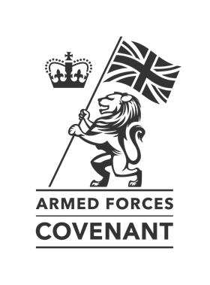
Introduction to the Armed Forces Covenant.

What is the Armed Forces Covenant?
At the height of the war in Afghanistan the UK Government published the Armed Forces Covenant – a promise from the nation and the government to its Service personnel, veterans and their families that they will be treated fairly and with respect.
At its heart is the principle that the armed forces community should experience no disadvantage when accessing public and commercial services.
In 2013 Charnwood Borough Council signed the Covenant.
The Council has a responsibility to The Armed Forces Community that they should not face disadvantage compared to other citizens in the provision of services, this could be in housing, education and social care; and that special consideration is appropriate in a minority of cases, such as the injured and the bereaved as examples of this.
It aims to:
•encourage local communities to support the armed forces community in their areas and to nurture public understanding and awareness among the public of issues affecting the armed forces community
•recognise and remember the sacrifices faced by the armed forces community
•encourage activities which help to integrate the armed forces community into local life
•encourage the armed forces community to help and support the wider community, whether through participation in events and joint projects, or other forms of engagement
Every Council has an Armed Forces Champion who is the lead member for the Covenant. At Charnwood this is Cllr Fryer.
What about “You can obtain more information from Vicky Coomber or Melinda Capewell who are involved with delivering the Council’s Covenant commitment”
We are encouraging all staff especially if your service has additional responsibilities as a result of our Covenant commitment, such as housing and all front line staff.
To find out more information at (Link to learning pool).

