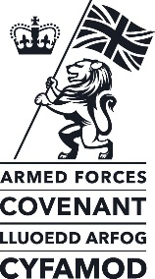
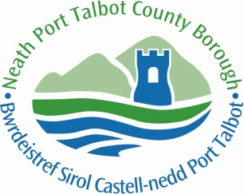
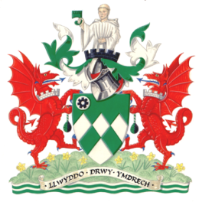

The Neath Port Talbot Mayor’s
Armed Forces Covenant Festival
PROGRAMME FOR THE FESTIVAL
20th October 2018

10.00am | Support for the Launch of the Poppy Appeal and the opening of the  Garden of Remembrance in the Aberavon Shopping Centre,  in conjunction with the Port Talbot Branch of the Royal British Legion
From 10.15am to  3.00 pm | The Mayor’s Armed Forces Festival  A Flag Raising Ceremony to open the Festival  To open the Festival in the Civic Square at 10.15 am  The Festival will include:  - A display outside the Civic Centre from the tri services of the Navy, Army and Air Force, including equipment and challenges for the young and not so young. Opportunities to meet the Regular Forces, Reservists and Cadets.  - A display of historic vehicles from World War Two.  - Displays and an opportunity for Veterans and the Families of Serving Personnel, to gather information from organisations that support them in the community, will be held in the Princess Royal Theatre, Port Talbot.
11.20am to  12.00 noon | A Plaque unveiling will take place in Talbot Memorial Park in Taibach,  which has been dedicated as a Field in Trust to commemorate the  100th Anniversary of the First World War.
7.00pm | An evening performance in the Princess Royal Theatre to celebrate and commemorate the contribution of the armed forces and civilians in Neath Port Talbot, especially in this centenary year of the end of World War 1.

