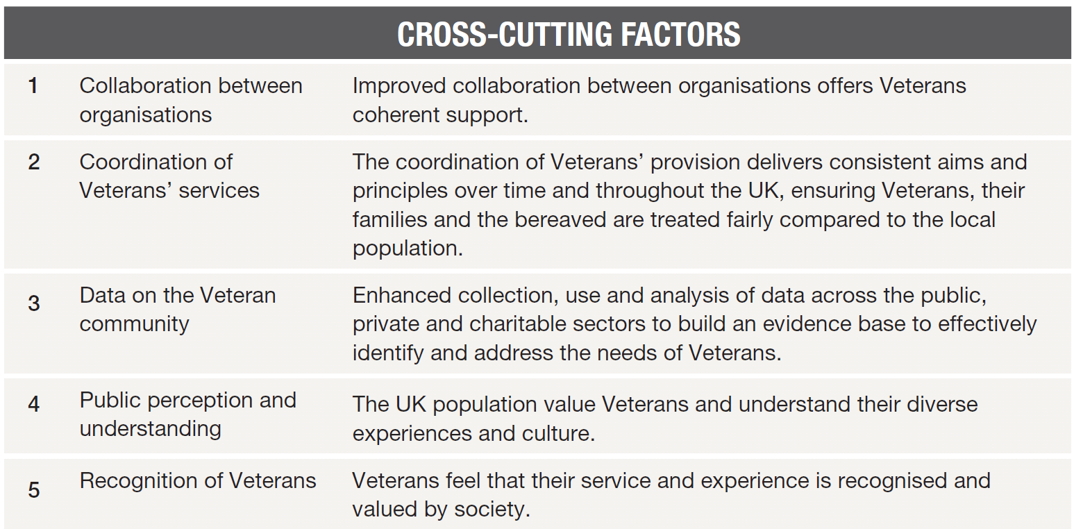
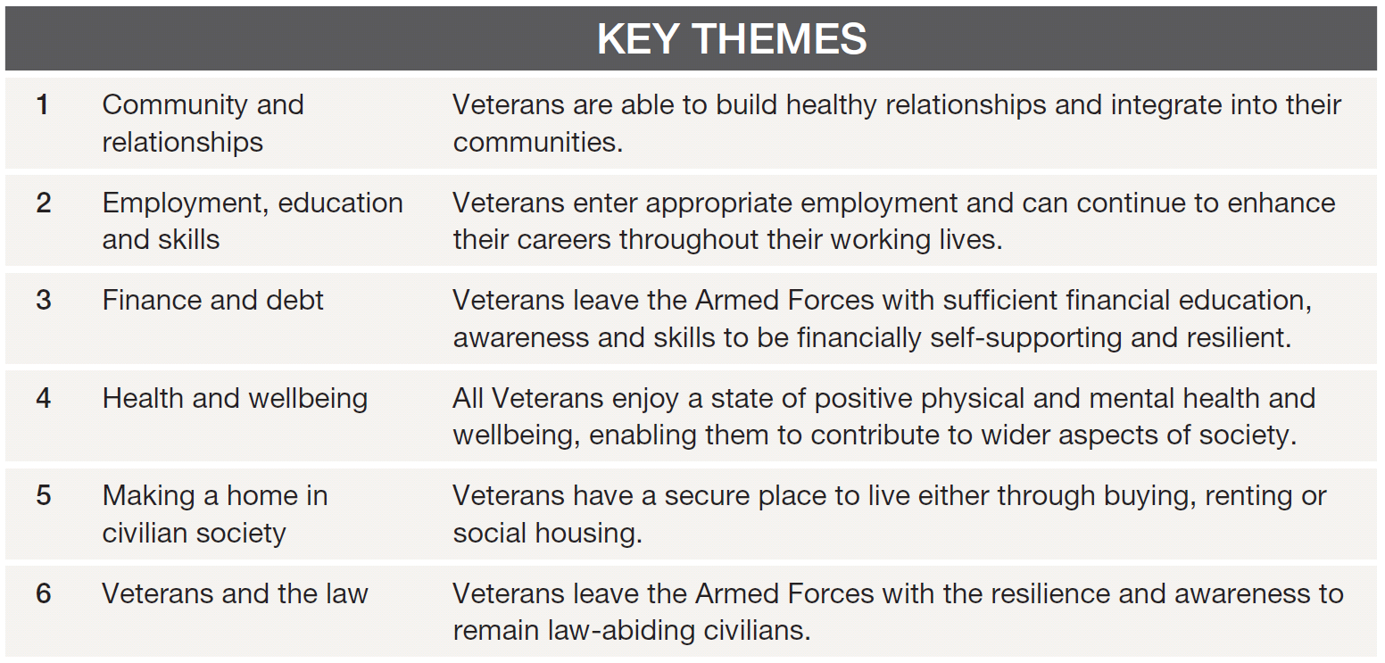
North Lincolnshire
Armed Forces Covenant Plan 2021
Organisations are working in partnership to fulfil the principles of the Armed Forces Covenant so that the Armed Forces community feel safe, well, prosperous and connected in North Lincolnshire.
NORTH LINCOLNSHIRE ARMED FORCES COVENANT PLAN 2019/20
The key principles of the North Lincolnshire Armed Forces Covenant are: Recognise, Remember, Integrate, Support
The Armed Forces Community comprises of serving personnel (both regular and reservists) and their dependents; and veterans and their dependents
The key themes of the plan reflect those of the Governments 10-year Veterans strategy
Theme Ref. | Outcome | Cross Cutting Factor | Future Action Point | Owner | Update
1.0  Community and relationships | 1.1 Data on the local Armed Forces community is regularly collated and monitored | Data, Collaboration
 | 1.2 The Armed Forces community in North Lincolnshire is encouraged to access support through positive media and/or events | Public perception, Recognition
 | 1.3 Public sector organisations and charities are supported in order to reduce social isolation among ex-serving personnel through the Armed Forces Hub and its virtual offer | Collaboration, Coordination
 | 1.4 There is support for service children in North Lincolnshire that require it through use of the Service Pupil Premium and existing family support services | Collaboration, Coordination
2.0  Employment, education and skills | 2.1 Data on ex-serving personnel and spouses who are seeking employment and/or education is collated and monitored | Data, Collaboration
 | 2.2 Opportunities for employment/training are promoted among the local Armed Forces community | Public perception, Recognition
 | 2.3 Local businesses are engaged with the Defence Employer Recognition Scheme | Public perception, Recognition |  |  | .
3.0  Finance and debt | 3.1 The level of need for finance/debt advice among the Armed Forces community in North Lincolnshire is determined | Data, Collaboration
 | 3.2 Finance/debt staff across organisations have access to appropriate Armed Forces Covenant training | Public perception, Recognition
4.0  Health and wellbeing | 4.1 Ex-serving personnel are identified on registration in local health and social care services | Data, Collaboration
 | 4.2 Health and Social Care organisations have access to Armed Forces Covenant training | Public perception, Recognition
 | 4.2 The need for mental health services for ex-serving personnel is determined | Collaboration, Coordination
 | 4.3 GP surgeries have access to information regarding the military accreditation scheme | Public perception, Recognition, Coordination
 | 4.4 Northern Lincolnshire and Goole Hospitals NHS Trust is ‘Veteran Aware’ | Public perception, Recognition, Coordination
5.0  Making a home in civilian society | 5.1 Housing departments and organisations have access to Armed Forces Covenant training | Public perception, Recognition
 | 5.2 Armed Forces community specific information is included in tenant packs and websites | Collaboration, Coordination
 | 5.3 Housing policies reflect latest Government guidance | Coordination
5.0  Veterans and the law | 6.1 Partner organisations are aware of referral methods for Project Nova | Collaboration, Coordination
 | 6.2 Partner organisations are aware of Project Nova App | Collaboration, Coordination, Public Perception

