An introduction to grant funding
Guidance for Armed Forces units and bases

What is AFCFT?
The Armed Forces Covenant Fund Trust (AFCFT) provides grants to support the Armed Forces community.
We award these grants through various targeted funding programmes, each designed to address specific needs within the community.
Our vision is for a thriving Armed Forces community that is valued and supported within society.

What is AFCFT Grant Funding?
AFCFT grant funding offers targeted opportunities to apply for funding for projects that benefit the Armed Forces community.
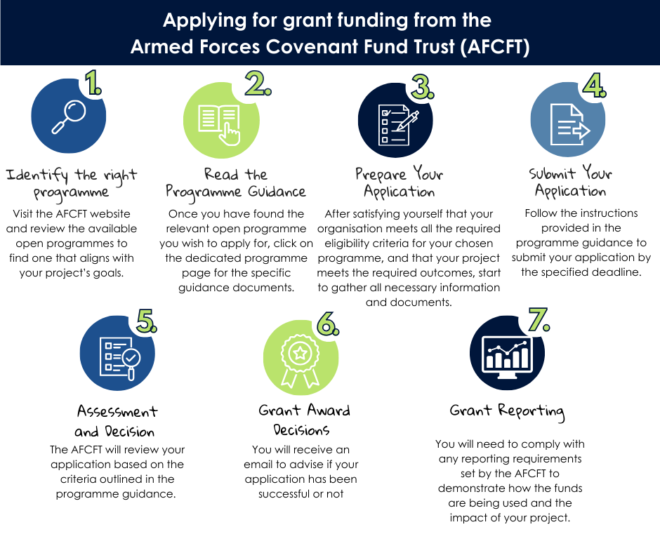
This includes serving personnel, Veterans, and their families. We award funding through specific programmes, each with its own objectives and eligibility criteria to address specific needs.
Steps to apply for AFCFT grant funding
- Identify the right programme:
  - You can find our open programmes on the AFCFT website Programmes - Armed Forces Covenant Fund Trust
- Review the available open programmes to find one that aligns with your project’s goals and check your eligibility to apply Eligibility Checker : Armed Forces Covenant Fund Trust
- Read the programme guidance:
  - Once you have found the relevant open programme you wish to apply for, click on the dedicated programme page. Here you will find specific guidance documents relating to that programme which outline eligibility criteria, application requirements, and assessment processes. Make sure to read these carefully.
- Prepare your application:
  - Once you are satisfied that your organisation meets all the required eligibility criteria for your chosen programme, and that your project meets the required outcomes, start to gather all necessary information and documents. This typically includes a detailed project plan, budget, and evidence of need within the community.
- This is a good time to speak with your CO/OC and ensure they endorse the project. Whilst not required at application stage they will be required to provide a supporting statement if your application is successful.

- Complete your application in Word, using the template you can download from the website programme page. You can then copy and paste your answers into our grants portal. This enables you to have a copy in the event of any IT issues.
- Submit your application:
  - Follow the instructions provided in the programme guidance to submit your application by the specified deadline.
  - Please note we are unable to accept late applications, so it is important to plan ahead to mitigate against external factors such as IT issues or time zone differences.
- Assessment and decision:
  - AFCFT will review your application based on the criteria outlined in the programme guidance. We may also consider your organisation’s past performance, and the proportion of funding requested relative to your overall income.
- Grant award decisions
You will receive an email to advise if your application has been successful or not.
- If your application is successful, you will be invited to a grant set-up call with your Grant Officer. We will accommodate time differences, if required.
  - If your application is unsuccessful, you will receive feedback on your application.
- Payment of your grant

- Your AFCFT Grant Officer will discuss your payment and reporting schedule for your project during your grant set-up call.
- Grant awards are paid in increments and are contingent upon satisfying reporting requirements. Ongoing reporting requirements such as Progress Reports and Snapshot Reports are important as they let us know how your project is progressing, and if any variations are required to how the project is being delivered or how the funding is being spent.
- Your first grant payment will be contingent upon a grant set-up call and on the receipt of a satisfactorily signed grant offer letter accepting the terms and conditions of the grant award. We will also request banking evidence, if we don’t already hold bank details for you. Any additional information required will be requested by your Grant Officer.
- The Trust will keep around 5% of the grant award back, this will be paid upon completion of your project and on receipt of a satisfactory End of Grant Report. We will expect you to spend the full grant award and this remaining 5% will be paid retrospectively.
8. Grant reporting:
- You will need to comply with any reporting requirements set by the Trust to demonstrate how the funds are being used and the impact of your project. Please note the payment of each instalment of your grant depends on you meeting the reporting requirements.
  - The Trust administers funding from HM Government, that means that your project has been funded through public money. For this reason, we need to ensure a high level of transparency on how the money has been spent and the impact that it had.
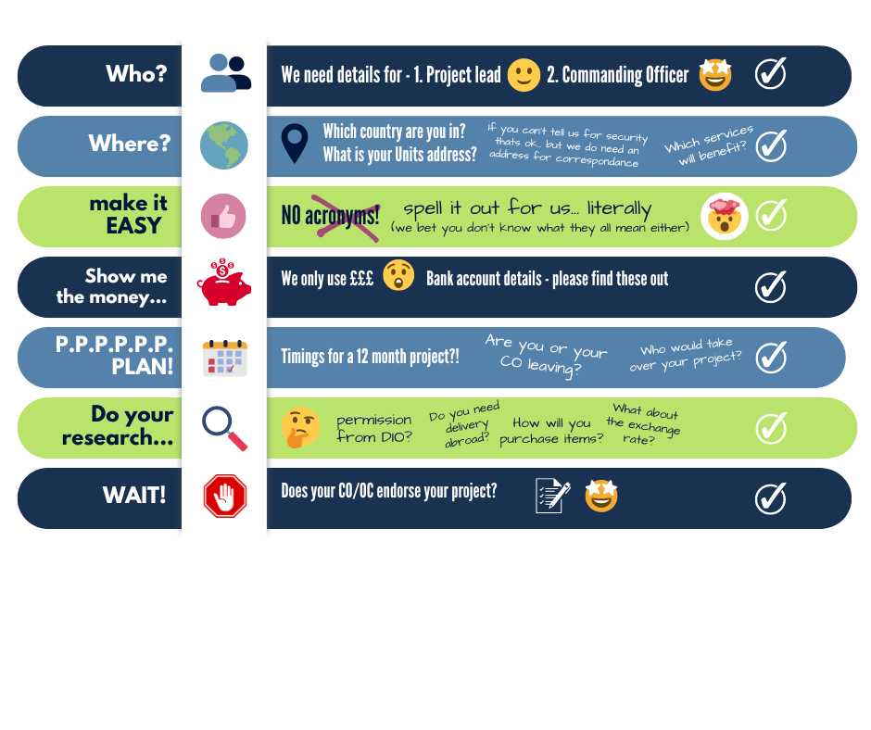

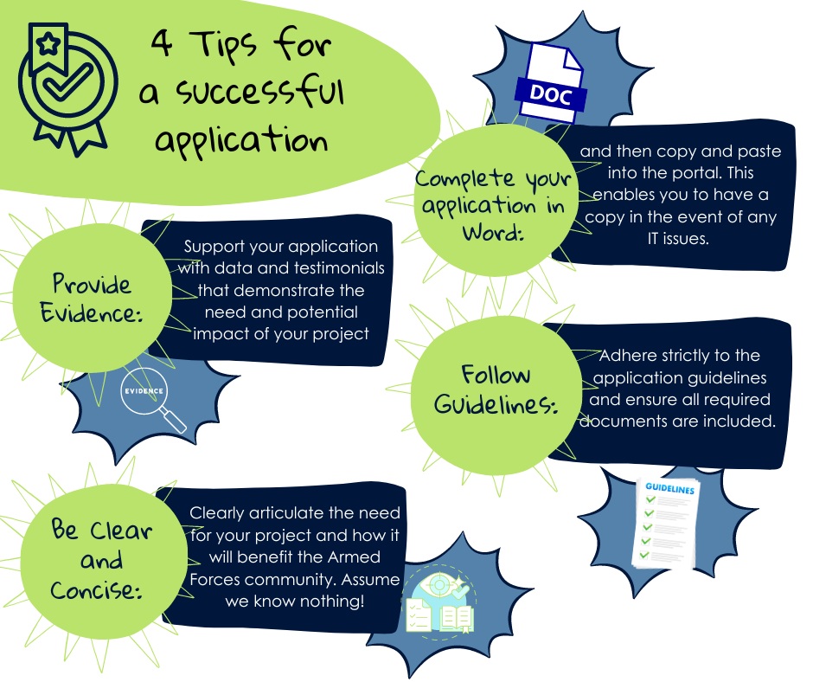
Do you have a dedicated bank account for any funds you are awarded?
Having a registered bank account is crucial when applying for funding.
It provides a secure and verifiable means for the Trust to transfer funds directly to the applicant. This ensures the funds are received safely and can be tracked easily.
Having a bank account simplifies the process of managing and utilising the restricted funds, allowing for better financial planning and accountability. Overall, a registered bank account is a fundamental requirement that facilitates the smooth and efficient handling of funds.

Conclusion
Applying for AFCFT grant funding can be a valuable opportunity to access resources that can help support the Armed Forces community. By understanding the specific requirements and following the application process carefully, you can increase your chances of securing funding for your project.
Please be assured if your application is successful, you will have a point of contact at the Trust who will be able to help with any questions you might have along the way.

